SIK Worksheets v.1.0 Name:
Voltage Drop Date:

Voltage drop is an important concept when you are creating circuits. Voltage drop is the amount that the voltage drops when it passes through a component. The following exercises will show how to measure voltage drop in real life. This is essential when you are fixing your remote control car or electric guitar or even a cell phone.

Measure voltage, current and resistance are all done in different ways. To measure voltage you connect your positive (red) multimeter lead to the side of the circuit that closer to your power source and the negative (black) multimeter lead to the side of the circuit that is closer to the ground. It is important to know how much voltage is going through a circuit for many reasons. The most important reasons being that too much voltage can damage your components and too little voltage may not power them fully.

Hook up the circuit to the right using red LEDs.  Close the circuit so only one LED is grounded with the 300Ω resistor. Insert the end of the resistor not plugged into the ground into a hole on the same row as the first LED's negative lead. The other LEDs don't light up, why is this?  Only the 1st LED is grounded, so it is the only LED with a closed circuit. The others are not grounded. Current takes shortest (least resistance) path to ground.  Measure the voltage drop across just the LED and record. _____________1.98v  Measure the voltage drop across the LED and the resistor. ____________4.92v  Close the circuit so two LEDs light up.  Voltage drop across one LED = _1.88v Voltage drop across two LEDs = _3.78v  Measure the voltage drop across the whole circuit and record. _4.95________v  Close the circuit so three LEDs light up.  Voltage drop across one LED = 1.66_v Voltage drop across two LEDs = _3.3_v  Voltage drop for three LEDs = _4.95v Voltage drop for whole circuit = _4.96v  What happened to the LEDs with the last question?  They get very dim. The LEDs are drawing less volts than they need to fully light.  Now hook up the same circuit to the 3.3V power source without the resistor.  Why do you think you don't need the resistor?  _The power source (3.3v) is less than the maximum voltage for the LEDS. _____________________________________________________________  Measure the voltage drop across all the LEDs and record. _____3.36___v  Close the circuit so two LEDs light up.  Voltage drop across one LED = _1.68v Voltage drop across two LEDs = 3.36_v  Hook up the circuit above to the 5V power source but use the 3.3v as ground.  Wait a second! You can't use a power source as a ground! Or can you?  What is the voltage available and how many LEDs can you light up with it?  Voltage available = __1.7____v # of LEDs you can light up = 1 (barely) | 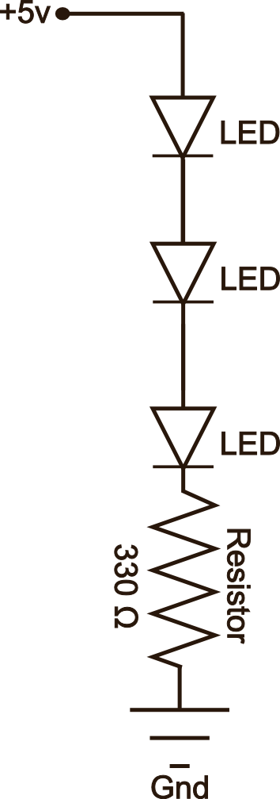  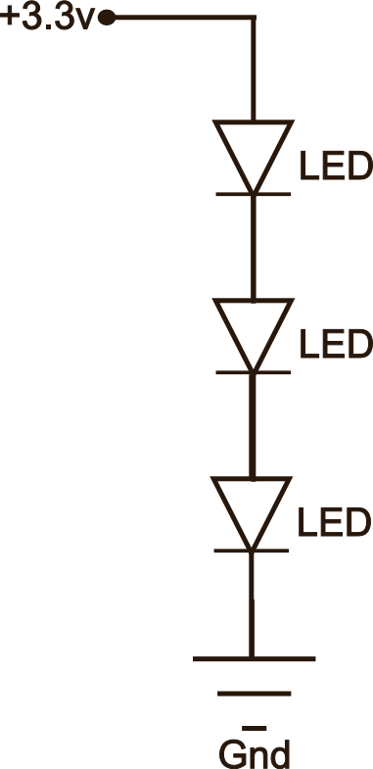

Many people think of Gnd as the ONLY place to connect a 'negative' pin, but all you need is a voltage drop from the beginning of a circuit to the end. This difference in voltage is what draws the current in the correct direction.

