SIK Worksheets v.1.0 Name:
Programming Concepts, Variables Date:

Vocabulary: Variable, Boolean, Integer, Character, Value

Variables are one of the most important concepts in computer programming. But what exactly are variables? Variables are like baskets that hold pieces of information. There are a couple different kinds of variables depending on what kind of information you need to keep track of. You have probably already heard of most of the different kinds of variables. Here are the definitions of three different kinds of variables. There are more types of variables, but to start with these are the most important types of variables.

Boolean variable: A boolean variable can be true or false (one or zero).

Integer variable: An integer variable can be any whole number from −32768 to 32767.

Character variable: A character variable can be any one letter (or punctuation or symbol).

Below is a robot, answer the questions to the right of the robot and be as silly as you want. Then write the type of variable you would use to store this information. For a boolean write “boolean”, for an integer write “int” and for a character write “char”.
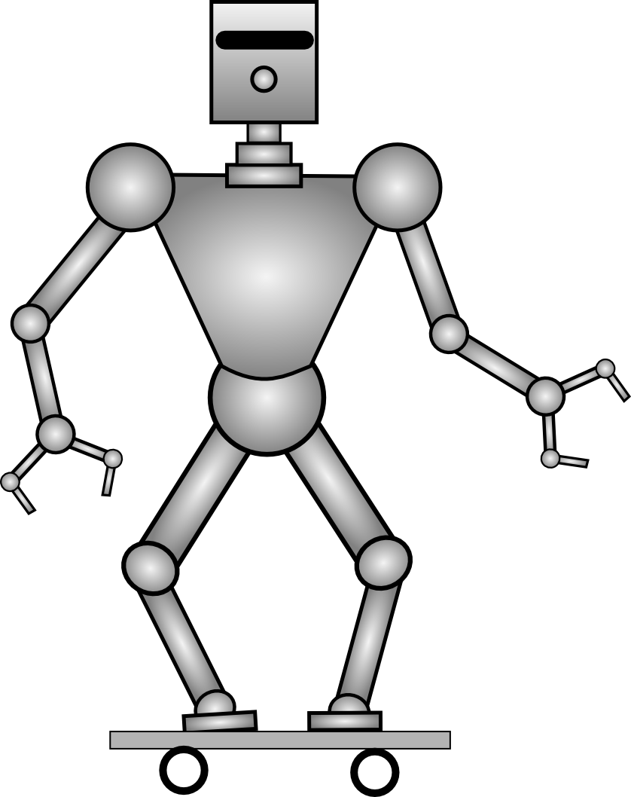 | Is this robot good at skateboarding? ______________  How old is this robot?_________  What is the first letter of this robot's name?_______________  How many years has this robot been skateboarding? _________  Is this robot wearing pants?____  What is the first letter of the robot's dog's name? __________  Is the robot going to crash? ____  How many feet of air has this robot gotten? _______________ | Variable type:_Boolean_______  Variable type:_Integer_______  Variable type:_Character_____  Variable type:_Integer_______  Variable type:_Boolean_______  Variable type:_Character_____  Variable type:_Boolean_______  Variable type:_Integer_______

The number, or character, you put into a variable is called its value. Once you have created a variable you can change the value whenever you need to. For example, if we decided the robot is 1000 years old, in a year we need to be able to change its age to 1001. First we need to create a variable to keep track of its age. We can name the variable whatever we want, but “age” makes sense so we'll go with that. Then we need to put a value into the variable. The first value was 1000, but a year later we delete that value and replace it with the new value, 1001. Pretty easy, huh? If we wanted to keep track of how old the robot used to be when we met it we could create a new variable called “ageWeMet”. That way when we have to change the “age” variable we can keep track of how old the robot was when we met it in the other variable “ageWeMet”. You may have noticed that there are no spaces in the name of this second variable. That is because variable names can't have any spaces in them.

Just to make sure you get it, circle the variable in the sentences below and put a box around the value.
SIK Worksheets v.1.0 Name:
Programming Concepts, Boolean Variables Date:

Vocabulary: Boolean, Declare, Assign

Wow! You're ready to start programming your first boolean variable. Anytime you see italics it is an example of how you would write something in the Arduino computer language.

A Boolean variable is the simplest kind of variable, it is either true or false.
True is represented by a one or HIGH and false is represented by a zero or LOW.

HIGH can be used as true but really it means there is electricity flowing through a circuit.
LOW can be used as false but really it means there is not electricity flowing through a circuit.

To create a Boolean variable you type the following: boolean variableName;

This is called “declaring” a variable.

The variableName can be anything you like, but it should make sense to you.

For example you could declare a Boolean variable named dayLight (boolean dayLight;) that represents whether it is daytime or not. Once you have declared your variable it is not equal to anything, it is empty and waiting for you to set it equal to true or false. To do this you type the following: dayLight = true; or dayLight = 1;. (Don't forget the ; at the end, it's very important! It is called a semicolon and it tells the computer that you are done doing something.)
This means that dayLight is true, and you can see the sun. Setting a variable equal to a value is called “assigning”. Declare three Boolean variables about the robot on this page in the spaces below and then assign them values of true or false (or one or zero). Remember, you can name the variables whatever you want! They're your variables, it's up to you. Look at the example above if you are unsure of how to declare and assign. (Don't forget the semicolons at the end of each line, they're important!)

Declare:
Assign:
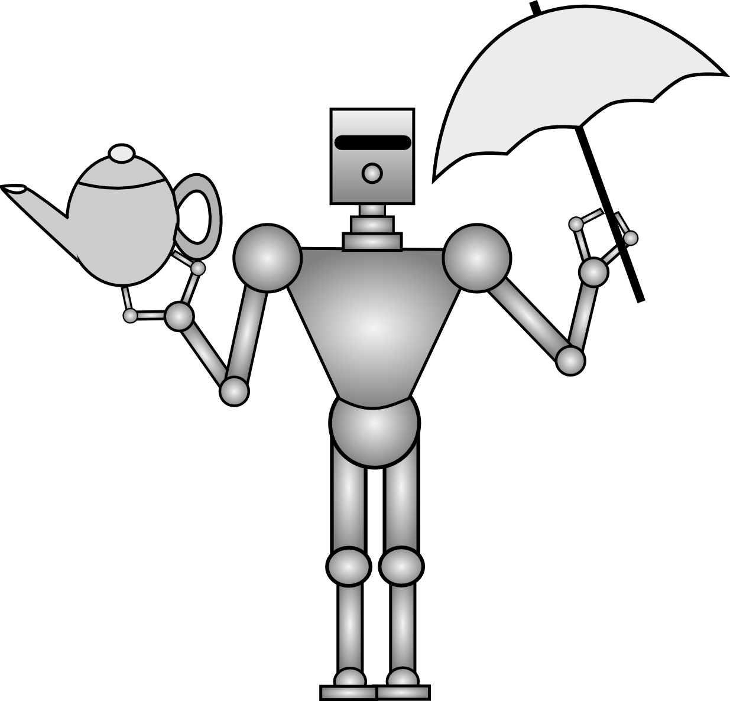
List three of the silliest things you can think of that you might keep track of with a boolean variable. Examples: Do I have peanut butter in my ear? Are penguins good to use as dodgeballs?
_____________________________________________________________________________________________________________________________________________________________________________________________________________________

Now pick one of the silly ideas above. In the space below declare your silly variable and then assign it a value. For example: boolean peanutButter; peanutButter = true; This means that I do have peanut butter in my ear... maybe I am saving it for lunch.
______________________________________________________________________________________________________________________________________________
SIK Worksheets v.1.0 Name:
Programming Concepts, Integer Variables Date:

Vocabulary: Integer, Declare, Assign

Wow! You're ready to start programming your first integer variable. Anytime you see italics it is an example of how you would write something in the Arduino computer language.

An Integer variable is a number (no fractions) between -32768 and 32767.

To create a Integer variable you type the following: int variableName;

This is called “declaring” a variable.

The variableName can be anything you like, but it should make sense to you.

To assign an Integer variable the value 120 you type the following: variableName = 120;

For example you could declare an Integer variable named clouds (int clouds;) that represents the number of clouds in the sky. Once you have declared your variable it is not equal to anything, it is empty and waiting for you to set it equal to a number between −32768 and 32767. To do this you type the following: clouds = 8;. (Don't forget the ; at the end. This is called a semicolon and it's how the computer knows you are done doing something.)
This means that you can see eight clouds in the sky. Setting a variable equal to a value is called “assigning”. Declare three Integer variables about the picture on this page in the spaces below and then assign them values between −32768 and 32767. Include at least one variable with a negative value and one variable with a value greater than ten. Feel free to make up variables and values that you can't actual see in the picture, just try to keep it sort of making sense. Look at the example above if you are unsure of how to declare and assign. (Don't forget the semicolons at the end of each line!)

Declare:
Assign:

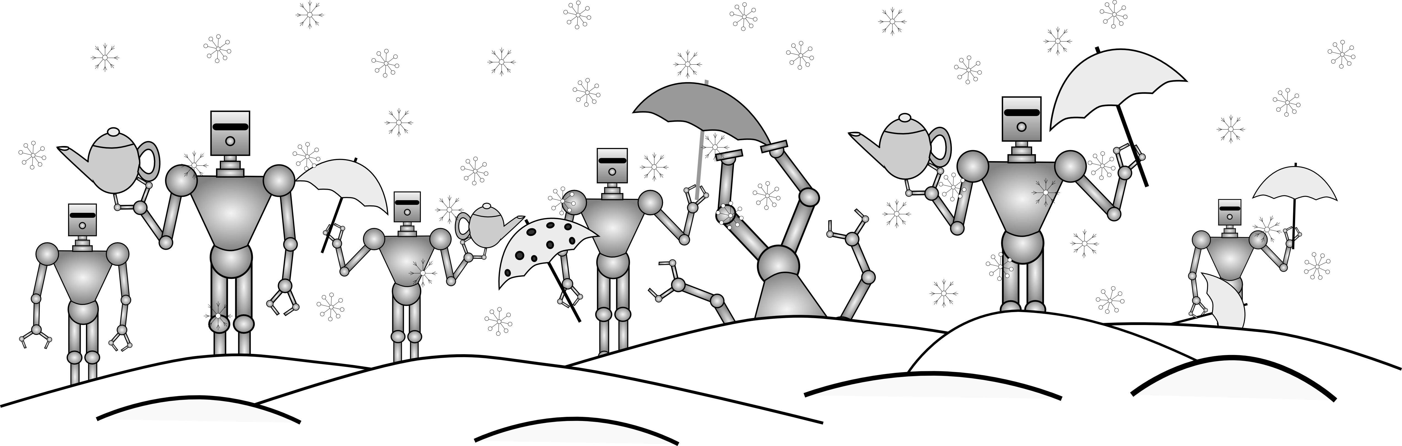
List three of the silliest things you can think of that you might keep track of with an integer variable. Example: How many pieces of ham do I have in my pocket? How many bugs could you fit in a rocket?
_____________________________________________________________________________________________________________________________________________________________________________________________________________________

Now pick one of the silly ideas above. In the space below declare your silly variable and then assign it a value. For example: int ham; ham = 10732; Either I have big pockets or small pieces of ham.
______________________________________________________________
SIK Worksheets v.1.0 Name:
Programming Concepts, Char Variables Date:

Vocabulary: Character, Declare, Assign

Wow! You're ready to start programming your first character variable. Anytime you see italics it is an example of how you would write something in the Arduino computer language.

A Character variable is a single letter, symbol or number.

To create a Character variable you type the following: char variableName;

This is called “declaring” a variable.

The variableName can be anything you like, but it should make sense to you.

To assign a Character variable the value “Q” you type the following: variableName = 'Q';

For example you could declare a Character variable named weather (int weather;) that uses a letter to represents the weather. You can use the letter R to mean it is raining, S for snow, and C for clear. Once you have declared your variable it is not equal to anything, it is empty and waiting for you to set it equal to a character. To do this you type the following: weather = 'C';. (Don't forget the ; at the end. This is called a semicolon and it's how the computer knows you are done doing something.) Also, the are many different character types other than a letter!?*%$&@
weather = 'C'; means that the sky is clear, but that's just because you decided it means that. C could mean whatever you need to keep track of. For example C could mean that it is cold out, if that's what you decided. Setting a variable equal to a value is called “assigning”. Declare three Character variables about the picture on this page in the spaces below and then assign them character values that make sense. Make sure to check the example when your are assigning a value, this can get tricky. Make sure the variable names describe the object you want to keep track of. Look at the example above if you are unsure of how to declare and assign. (Don't forget the semicolons at the end of each line!)

Declare:
Assign:
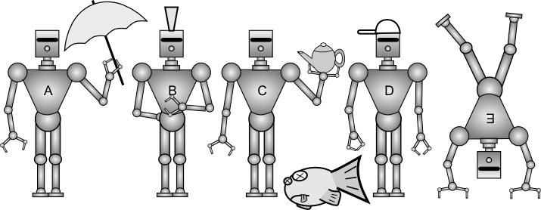

List three of the silliest things you can think of that you might keep track of with a Character variable. Example: How many pieces of ham do I have in my pocket? How many bugs could you fit in a rocket?
__________________________________________________________________________________________________________________________________________________________________________________________

