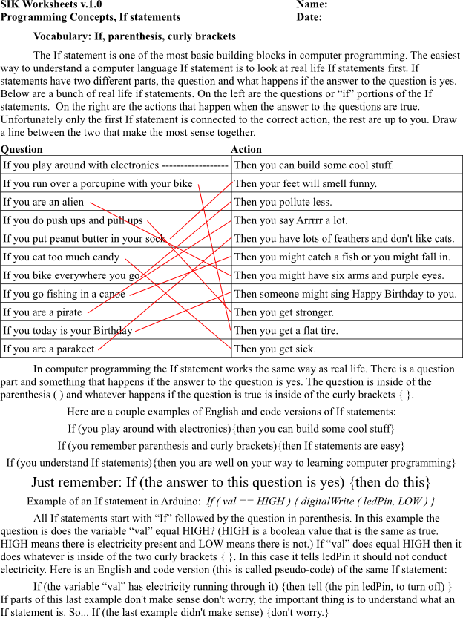
SIK Worksheets v.1.0 Name:
Programming Concepts, If statements Date:

Write three of the silliest, or most interesting, If statements you can think of in the space below, don't worry about putting them inside of parenthesis and curly brackets, we'll get to that later.

Example 1: If dinosaurs were still alive then we would have to run when we were outside.
_____________________________________________________________________________________________________________________________________________________________________________________________________________________

Now write your If statements the way they would look with the parenthesis. Don't forget the difference between the two different kinds of parenthesis!

Example 1: If (dinosaurs were still alive) {then we would have to run when we were outside.}
__________________________________________________________________________________________________________________________________________________________________________________________

But what if there are two or more things that could happen if the question is true?

Example 2: If dinosaurs were still alive then we would have to run when we were outside, but if they were our pets we could walk and we would need really big liter boxes.

Is this really just one If statement? No, it's actually two, and one of the If statements is inside the other. Don't worry! This is ok, in fact it happens all the time. Here is how it looks in pseudo-code:

Example 2: If (dinosaurs were still alive){
then we would have to run when we were outside, but
If (they were out pets) {
we could walk and we would need really big liter boxes} }

It may look complicated but it's just one If statement inside of another. There is no limit to how many Ifs you can put inside of an If statement. Go ahead and write one If statement with another If statement inside of it in plain English below. Make sure you use the word “if” twice.
______________________________________________________________________________________________________________________________________________

Now you're going to take that sentence and turn it into pseudo-code. Pay attention to where the parentheses and curly brackets are and how many there are. Start with writing the first question, put a curly bracket just after the question like this { and then put a curly bracket at the very end of the lines like this }. Now put what happens when the question is true and the second If statement inside of your first two curly brackets. If (you're confused) {look at example number two.}
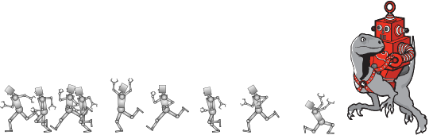
______________________________________________________________________________________________________________________________________________
SIK Worksheets v.1.0 Name:
Programming Concepts, If statements Date:

Now that you understand the basics of If statements you're going to practice filling in various parts of some If statements. These If statements are not written in code, but you should be getting comfortable with what goes where as well as the parenthesis and curly brackets. Remember, you will only do what is in the curly brackets if the question is true. Fill in the blanks and if you feel like it make them funny.

If ( _______________________________________________ ) { then you can fly. }

( your dog runs away ) { then you need to go looking for your dog. }

If ( you are hungry ) { _________________________________________________ }

If ____________________________________________________ { then you burp. }

If ( you want to become an astronaut ) { ___________________________________ }

If ( ________________________________ ) { ______________________________ }

( you build a robot ) { ________________________________________________ }

If you build an electronic drum set { then you can play drums without making noise.}

If ( you are an elephant ) { _______________________________________________ }

( you make pancakes ) _______________________________________________

If ( __________________________________________ ) { you should hit the pinata. }

( you want pizza ) __________________________________________________

