SIK Worksheets v.1.0 Name:
Circuit 13, Middle School Date:

Now we're starting to work with some more complicated sensors. The flex sensor has tons of real world applications. List three and explain why you can't use a regular potentiometer instead of a flex sensor. Example: use the sensor to measure the flex on a fishing pole and cut the line if the pole ever comes close to breaking. You could not use a potentiometer because it would be difficult to attach it.
_______________________________________________________________________________________________________________________________________________________________________________________________________________________________________________________________________________________________________________________________________________________________________________________________________________________________

Got your flex sensor and servo working? Great, but what if you want to measure flex in both directions? Add the necessary components to the schematic below (add components on right) and describe (in plain English) what you would need to add to the code to keep the single servo as your output with your new schematic.
__You would need to set zero flex on both sensors as 90 degrees on servo and map full bend of each as either 180 degrees or zero degrees respectively. The sensor that represents 0 – 90 degrees would need to go cause the servo to go down as it's value goes down and the other the opposite. Then place the flex sensors back to back. __________________________________________________________

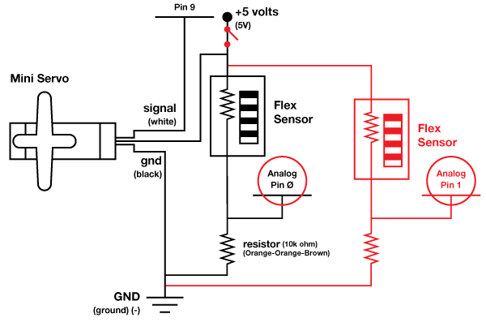  Unplug the flex sensor completely and look at your Serial Communication window. You should still be getting some values even though there is no sensor plugged in. This is due to something called “float” which occurs when an Arduino pin is expecting input  but there is no sensor attached to it. What is the highest value you receive and why is it important to know about float?  ___Float will be anywhere between zero and the voltage of your positive line. Most often around 2.5 v. Switches that are open often float so you don't know what their value is, sometimes there will be float due to broken sensors or unconnected wires.  What if you wanted your flex sensor to measure a smaller range of flexing (because what you are measuring is less flexible), but you want the same range of motion for your servo, how could you make it do that?  __Map a smaller sensor variable range to the same servo range.________________________________ ____________________________________________________________________________________________________________________________________________________________________________________________________________________________________________________________ | Add an On/Off switch to your schematic.  Circle any Arduino pins that take input on your  modified schematic.
Imagine your flex sensor is thirty feet long. List at least three things you could do with it.
______________________________________________________________________________________________________________________________________________________________________

