SIK Worksheets v.1.0 Name:
Circuit 14, Middle School Date:

The soft potentiometer is touchy, sometimes you will notice incorrect readings due to how you touch the sensor. The RGB will even change a little just before you touch the sensor! Explain how this alters the ways in which you can use this sensor. Explain at least one possible fix or work around.
____________________________________________________________________________________________________________________________________________________________________________________________________________________________________________________________________________________________________________________________________________

Got your soft potentiometer and RGB LED working? Great. Without looking at the code too much, mark on the soft potentiometer diagram below which areas cause which colors to be displayed.
Blue Green Red

Add the underlined code to your Arduino code.  In Setup: Serial.begin(9600);  In Loop after all other code: Serial.println(sensorValue);  delay(100);  Now open the Serial Communication window.  This will let you see the values (slowed down a little with the delay line, to see real time output remove delay(100);) as the soft potentiometer outputs them. What happens to the values after you stop touching the sensor? Explain why you think this happens. You may have to look up how this sensor works to figure this out.  __The values don't go down immediately to zero. They take a little time to do so. This is because the two layers of the potentiometer tends to stick together a little.____________________________ ___________________________________________________________________________________________________________________________  Explain in your own words how you think you could use the soft potentiometer to turn the RGB LED on/off as well as controlling the color. ___Change the values of the mapping procedure so the upper most and lower most values are not used to create a color, then assign those values (say 0 – 5 and 1018 – 1023) to LOW and HIGH, or OFF and ON. _____________________________________________________________________________________________________________________________________________________________________________________________________________ | 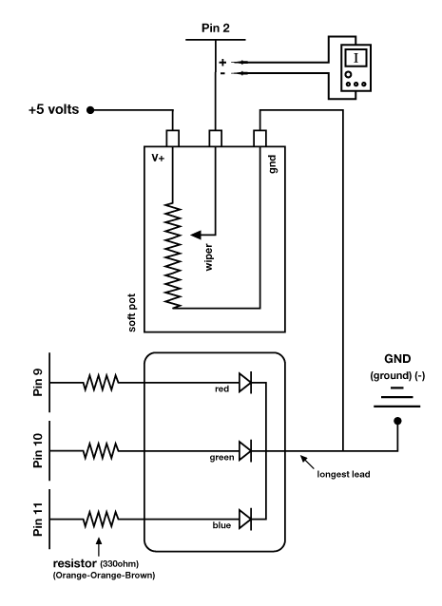  Measure resistance of the potentiometer when it is  blue, then green, then red. You will need to  disconnect the circuit because you can't measure  resistance while there is a current running through it.  Blue: 8K-10KΩ Green:3K-5KΩ Red: 0-20Ω
SIK Worksheets v.1.0 Name:
Circuit 14, Middle School Date:

Soft potentiometers come in a bunch of shapes and sizes. Explain how you can combine multiple soft potentiometers to create a basic touchscreen interface with Y and X position output.... or just go build one instead of explaining how it might work. You've finished the SIK, what are you waiting for? In fact, forget these guiding questions, if you want just use this page to brainstorm what your next project will be.
_____________________________________________________________________________________________________________________________________________________________________________________________________________________________________________________________________________________________________________________________________________________________________________________________________________________________________________________________________________________________________________________________________________________________________________________________________________________________________________________________________________________________________________________________________________________________________________________________________________________________________________________________________________________________

