SIK Worksheets v.1.0 Name:
Circuit 12, Middle School Date:

This LED has three inputs and three outputs. What other circuits have three inputs? Three outputs? Provide an example of each.
_________________________________________________________________________________________________________________________________________________________________________________________________________________________________________________________

Does the RGB LED work? Great. Upload the Circ12Expansion Code to your Arduino, add a trimpot, a temperature sensor and a photoresistor to the circuit. Connect the trimpot to analog pin 1, the temperature sensor to analog pin 2, and the photoresistor to analog pin 0. Use some of the previous circuit schematics if you get stumped. You may also switch out the temperature sensor for the flex sensor or soft potentiometer so you have more control of the RGB LED if you like, but you will also need to change the code a little.

Connect a multimeter to each line that is connected to an Arduino pin. Notice how the voltage changes while you use the sensor or interface coupled with each pin.  What should the voltage values for each pin be to make the RGB LED as red as it will get?  Pin 11 V = __0_v Pin 10 V = __0_v Pin 9 V = __5_v  What does “RGB LED” stand for?  ____Red Green Blue Light Emitting Diode _________________________________________  What do you think “RGBY LED” stands for?  ____Red Green Blue Yellow Light Emitting Diode _________________________________________  Add an On/Off switch to your schematic. | 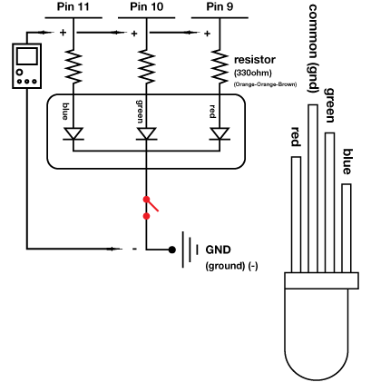
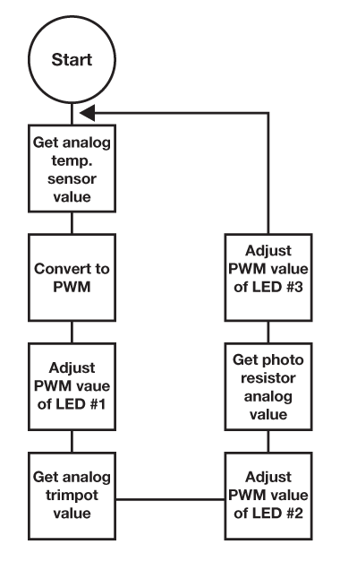  Draw a logic flow chart of the expanded circuit here: | Draw one example of how this circuit could be used in everyday life. Label all components and give it a title.
Other than making projects pretty, what are some possible uses for a RGB LED? List at least three.
______________________________________________________________________________________________________________________________________________________________________

