SIK Worksheets v.1.0 Name:
Circuit 11, Middle School Date:

How is this circuit, or a circuit like it, used in everyday life? Provide at least three examples.
_________________________________________________________________________________________________________________________________________________________________________________________________________________________________________________________

Does your relay work? Great. Upload Circ11Expansion Code to your Arduino, then add a button to your circuit and to the right of the schematic, make sure you include a pull down resistor (a 10KΩ resistor).
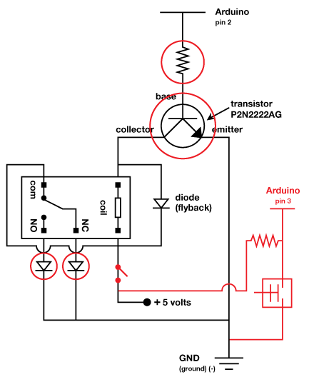
Name one thing you would have to change to use a potentiometer to control the relay instead of a button, extra credit for writing what you would need to add in the code as well. Use your own words, not code.
__No pull down resistor, analogRead not digitalRead_____________________________________________________________________________________________________________________________________________________________________________________________________________________________________________

If the NO in the relay stand for Normally Open, what do you think NC stands for?
______Normally Closed____________________

Circle the transistor.

Circle all diodes.

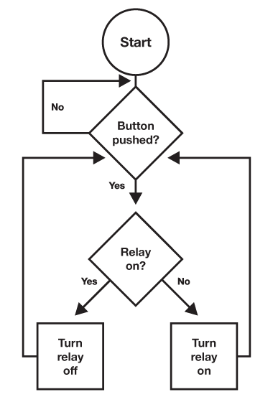  Draw a logic flow chart of the expanded circuit here: | Draw one example of how this circuit could be used in everyday life. Label all components and give it a title.
Imagine your perfect relay machine. What two things would your relay switch back and forth between and why? Get creative. Example: a soft serve ice cream machine and an electric caramel pump so that making sundaes would be a little less work and give you more time to eat them.
_________________________________________________________________________________________________________________________________________________________________________________________________________________________________________________________

