SIK Worksheets v.1.0 Name:
Circuit 10, Middle School Date:

How is this circuit, or a circuit like it, used in everyday life? Provide at least three examples.
_________________________________________________________________________________________________________________________________________________________________________________________________________________________________________________________

Does your temperature sensor work? Great.

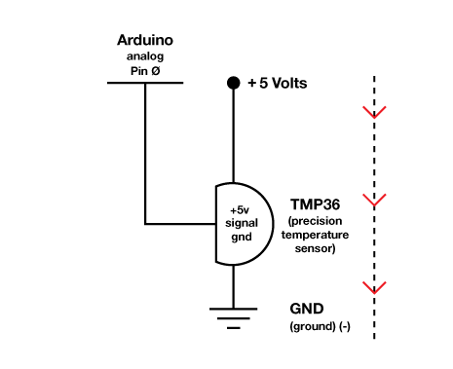
What line in the code displays the temperature?
___Serial.println(temperature);________________
__________________________________________________________________________________

What other line in the code is necessary to establish communication with your computer so it can display the temperature?
___Serial.begin(9600);____________________________________________________________
_________________________________________

Upload the Circ10Expansion Code to your Arduino, then add an LED and a resistor to the circuit. Control the LED's brightness with the temperature sensor. By now you should be able to do this without help, but here's a hint anyways: PWM pins = 3, 5, 6, 9, 10, 11

Draw arrows on the dotted line to indicate direction of current flow.

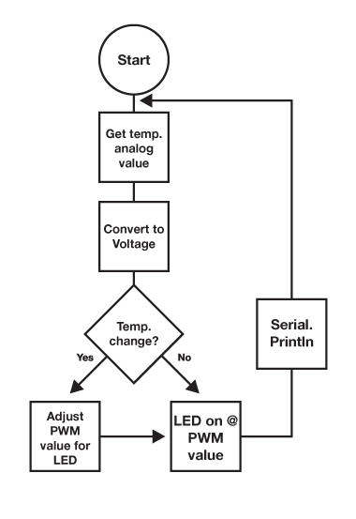  Draw a logic flow chart of the expanded circuit here: | Draw one example of how this circuit could be used in everyday life. Label all components and give it a title.
What ways, other than controlling an air conditioner, could a temperature sensor be useful? List at least three and explain what is controlled by the temperature sensor in each.
_________________________________________________________________________________________________________________________________________________________________________________________________________________________________________________________

