SIK Worksheets v.1.0 Name:
Circuit 9, Middle School Date:

How is this circuit, or a circuit like it, used in everyday life? Provide at least three examples.
_________________________________________________________________________________________________________________________________________________________________________________________________________________________________________________________

Can you turn your LED up and down using the photoresistor? Great.

Add the underlined to the circuit code and upload:  In Setup: Serial.begin(9600);  In Loop after all other code: Serial.println(lightValue);  Now open the Serial Communication window.  Replace the LED component (in the space below the schematic on the right) with an element or component from one of the previous circuits, extra credit if you decide to replace it with a motor and do so correctly.  Make sure an aspect of the element or component is controlled by the photoresistor. Example: replace LED with Piezo and control pitch with potentiometer.  Aspect controlled: _Pitch, speed or position_____  Why does this circuit use an analog pin as an input?  ____Because the photoresistor is an analog sensor. ________________________________________________________________________________________________________________________________________________________________________  Circle all resistors. | 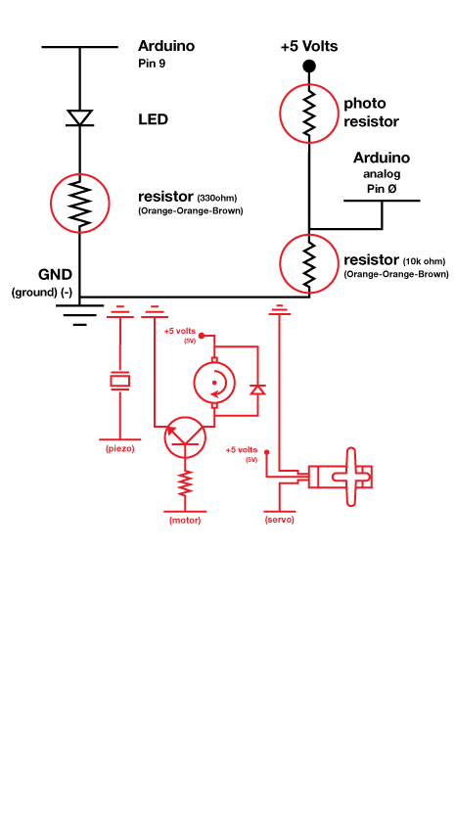
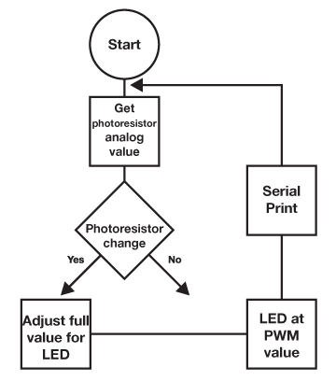  Draw a logic flow chart of the circuit (with Serial) here: | Draw one example of how this circuit could be used in everyday life. Label all components and give it a title.
The output variable lightValue can go all the way up to 900 but your LED input can only go up to 255. What word in the code fixes this and how would you describe this action in a mathematical sense?.
______”Map” is the word that does this in the code. It is similar to multiplication with addition or subtraction afterward in the order of operation. Addition and subtraction do not always occur. _______

