SIK Worksheets v.1.0 Name:
Circuit 8, Middle School Date:

How is this circuit, or a circuit like it, used in everyday life? Provide at least three examples.
_________________________________________________________________________________________________________________________________________________________________________________________________________________________________________________________

Can you turn your LED up and down using the potentiometer? Great. Pay attention to this circuit, potentiometers (also called trimpots) are great for creating analog user interfaces. With a potentiometer there are up to 1024 settings on a single dial!
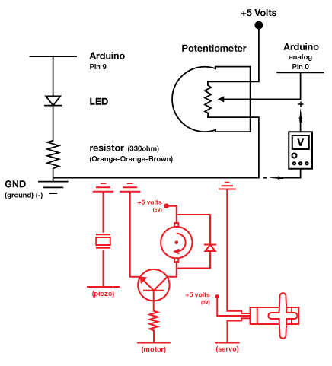
Add the underlined to the circuit code and upload:
In Setup: Serial.begin(9600);
In Loop after all other code: Serial.println(sensorValue);
Now open the Serial Communication window.

Replace the LED component (in the schematic) with an element or component from one of the previous circuits,
extra credit if you decide to replace it with a motor.
Explain which aspect of the element or component is controlled by the potentiometer. Example: replace LED with Piezo speaker and control pitch with potentiometer.
Aspect: _Pitch, speed, or position______________

Use your multimeter as indicated and measure the voltage of the potentiometer circuit while you turn the dial up and down. Explain below what happens.
_____It goes up and down depending on if you turn the potentiometer up or down._____________

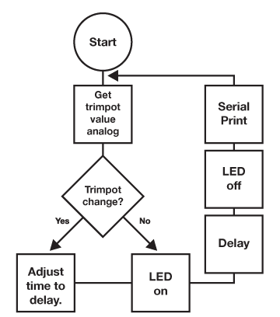  Draw a logic flow chart of the circuit (with Serial) here: | Draw one example of how this circuit could be used in everyday life. Label all components and give it a title.
Potentiometers are everywhere. List at least three appliances that use potentiometers as an input. Also list what the potentiometer input controls (also known as an output).
____________________________________________________________________________________________________________________________________________________________________________________________________________________________________________________________________________________________________________________________________________

