SIK Worksheets v.1.0 Name:
Circuit 7, Middle School Date:

How is this circuit, or a circuit like it, used in everyday life? Provide at least three examples.
_________________________________________________________________________________________________________________________________________________________________________________________________________________________________________________________

Can you turn your LED on and off using both buttons? Great. Pay attention to this circuit, buttons are one of the most basic forms of user interface.
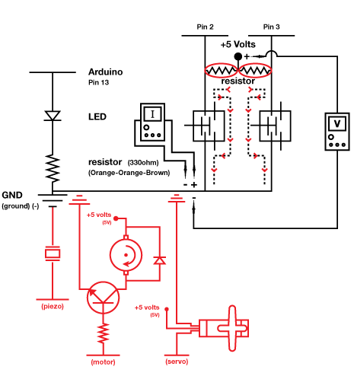
Give values for Voltage, Current and Resistance for each question. Find Current either by breaking the circuit and using your multimeter.  Button on pin 2 pushed:  V = ___5__v I = ___.48_mA R = _10416Ω  Button on pin 3 pushed:  V = ___5__v I = ___.48_mA R = _10416Ω  Think about the question above. What makes the LED turn on and off? _The code in the Arduino and the pin # 13______________________________________  If the resistor's value is 10000Ω, what is the resistance of the button? ________416_________Ω  Replace the LED component (in the space below the schematic to the right) with an element or component from one of the previous circuits. Extra credit if you decide to replace it with a motor.  Circle the resistor with the largest value. | Draw arrows to indicate direction of current on dotted line.
Draw a logic flow chart of the circuit here:  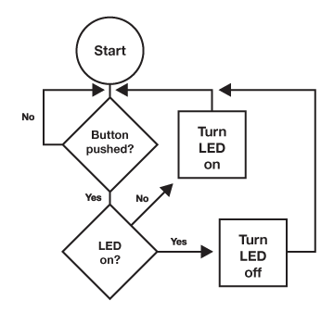  Use the back of this worksheet if necessary. | Draw one example of how this circuit could be used in everyday life. Label all components and give it a title.
Buttons are everywhere. List at least two different kinds of buttons that you might not think of as being buttons. Examples: piano keys and go Google “reed switches”. Now list at least two items that are not technically buttons, but could be used as buttons. Example: snaps on a shirt.
_________________________________________________________________________________________________________________________________________________________________________________________________________________________________________________________

