SIK Worksheets v.1.0 Name:
Circuit 6, Middle School Date:

Ohm's Law: V = I * R I = V / R R = V / I

How is this circuit, or a circuit like it, used in everyday life? Provide at least three examples.
_________________________________________________________________________________________________________________________________________________________________________________________________________________________________________________________

Got the annoying song blaring out of your tiny speaker? Great. Upload Circ06Expansion Code to your Arduino.

Give values for Voltage, Current and Resistance for each note value. Find Current by breaking the circuit and using your multimeter. Record voltage to the thousandths place. Calculate Resistance using Ohm's Law.  Note A: V = __.689v I = ___39.2_mA R = _18Ω  Note C: V = __.681v I = ___38.7_mA R = _18Ω  Note E: V = __.684v I = ___38.8_mA R = _18Ω  Note G: V = __.686v I = ___39.1_mA R = _18Ω  What does the Arduino pin # 9 do in this circuit?  ___Provides on and off values to make sound.  Draw arrows indicating current direction on dotted line.  Add another Piezo Element to the schematic so you can write harmonies. Be sure to show which Arduino pin you will attach it to.  Add an on/off switch to this schematic. | 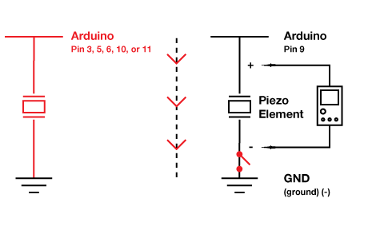
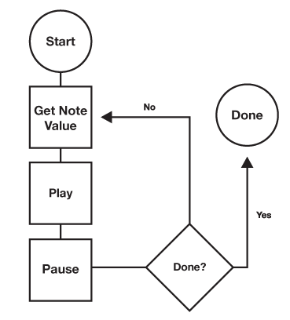  Draw a logic flow chart of the circuit here: | Draw one example of how this circuit could be used in everyday life. Label all components and give it a title.
Other than annoying your friends, how could you use the Piezo Element in a project? Example: create a timer that plays an annoying song faster and faster as time runs out. Write at least two examples.
_________________________________________________________________________________________________________________________________________________________________________________________________________________________________________________________

