SIK Worksheets v.1.0 Name:
Circuit 5, Middle School Date:

Shift Registers are used to control multiple pins using only three input pins to set the output pins. This can be useful if you want to control more than three objects using only three pins (as long as they always operate in the same order). What objects would you control using a shift register? List at least four and make sure the objects make sense together. Ex: A waffle iron, an eggbeater, a servo to pour the batter, and a timer.
_________________________________________________________________________________________________________________________________________________________________________________________________________________________________________________________

What does the Arduino pin # 2 do in this circuit?  _Sends binary data to shift register pins.___  What does the Arduino pin # 3 do in this circuit?  _Pulses clock so register knows to shift a bit._  What does the Arduino pin # 4 do in this circuit?  _Latches ability to write to shift register either true or false.  If all the LEDs are turned on, what would have to happen in order for LED # 5 to turn off?  _LEDs # 0 -4 would have to turn off first (by pulling latch HIGH, bitshifting in a zero and pulsing clock._ | 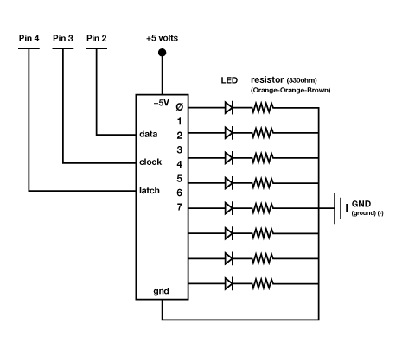
Draw a logic flow chart of the circuit here: You can limit the diagram to one of the LEDs.  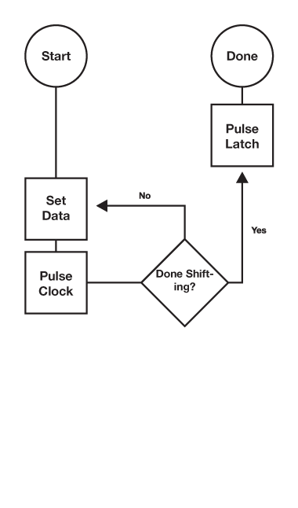 | Draw one example of how this circuit could be used in everyday life. Label all components and give it a title.
Using the circuit exactly as it is, with eight LEDs, what applications can you think of for the shift register? List at least three and explain what each LED would indicate.
_____________________________________________________________________________________________________________________________________________________________________________________________________________________________________________________________________________________________________________________________________________________________________________________________________________________________________________________________________________________________________________________________________________________________________________________________________

