SIK Worksheets v.1.0 Name:
Circuit 4, Middle School Date:

Ohm's Law: V = I * R I = V / R R = V / I

How is this circuit, or a circuit like it, used in everyday life? Provide at least three examples.
_________________________________________________________________________________________________________________________________________________________________________________________________________________________________________________________

Got your servo running? Great.
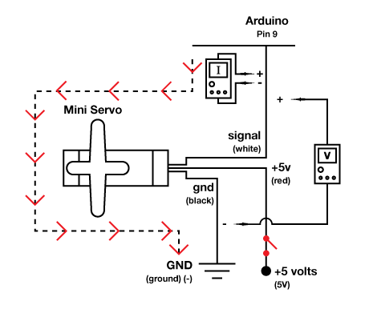
Give values for Voltage, Current and Resistance for the pin # 9 value while the servo is in motion. Find the current by breaking the circuit and measuring on signal wire. Find resistance using Ohm's Law.

Highest reading while Servo is in motion:

V = ___.4__v I = .03_mA R = 13333Ω

What does the Arduino pin # 9 do in this circuit?
_Provides the position to set the servo to.

Draw arrows to indicate direction of current on the dotted line.

Add an on/off switch to this schematic.

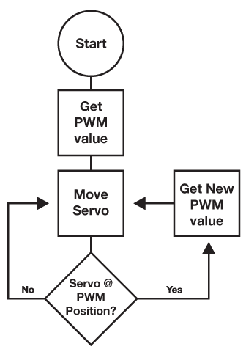  Draw a logic flow chart of the circuit here: | Draw one example of how this circuit could be used in everyday life. Label all components and give it a title.
A Servo can't rotate continuously more than 360 degrees, as opposed to a motor which can turn all the way past 360 degrees as many times as you like. However, a servo remembers what its position is while a motor only knows if it is running forward or backwards. Can you think of any situations in which you would need a Servo instead of a motor? How about the other way around? Write three examples, at least one of each, below.
_______________________________________________________________________________________________________________________________________________________________________________________________________________________________________________________________________________________________________________________________________________________________________________________________________________________________

