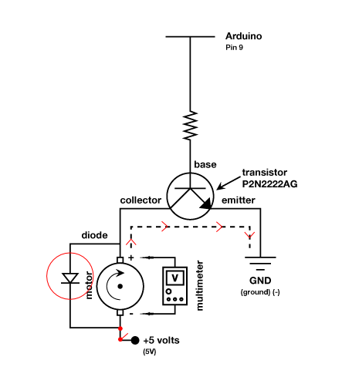
SIK Worksheets v.1.0 Name:
Circuit 3, Middle School Date:

Ohm's Law: V = I * R I = V / R R = V / I

How is this circuit, or a circuit like it, used in everyday life? Provide at least three examples.
_________________________________________________________________________________________________________________________________________________________________________________________________________________________________________________________

Got your motor running? Great. Load the Circ03Expansion Code. Fill in the answers below.

Give values for Voltage, Current and Resistance for each motor value. Find Current by breaking the circuit and using your multimeter. Calculate the Resistance using Ohm's Law. Record all values to the hundredths place.

Motor 50%

V = __1.1_v I = __34.4_mA R = __31Ω
Motor 60%

V = _1.55_v I = _40.4_mA R = __38_Ω
Motor 75%

V = _2.48_v I = 51.2_mA R = ___48_Ω
Motor 100%

V = _4.2__v I = _66.5_mA R = ___63Ω

Circle the diode.

Draw arrows to indicate direction of current on dotted line.

Add an on/off switch to this schematic.

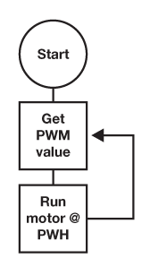  Draw a logic flow chart of the circuit here: | Draw one example of how this circuit could be used  in everyday life. Label all components and give it a  title.
How would you use this circuit if you were an engineer? Would you make a break-dancing robot penguin? To move a trapdoor? To make a yo-yo that plays itself? Get creative.
____________________________________________________________________________________________________________________________________________________________________________________________________________________________________________________________________________________________________________________________________________

