SIK Worksheets v.1.0 Name:
Circuit 2, Middle School Date:

Ohm's Law: V = I * R I = V / R R = V / I

How is this circuit, or a circuit like it, used in everyday life? Provide at least three examples.
_________________________________________________________________________________________________________________________________________________________________________________________________________________________________________________________

Got your LEDs turned on? Great. Load the Circ02Expansion Code. In this code the last LED pin is an analog output using PWM (Pulse Width Modulation). Make sure to use a red LED.
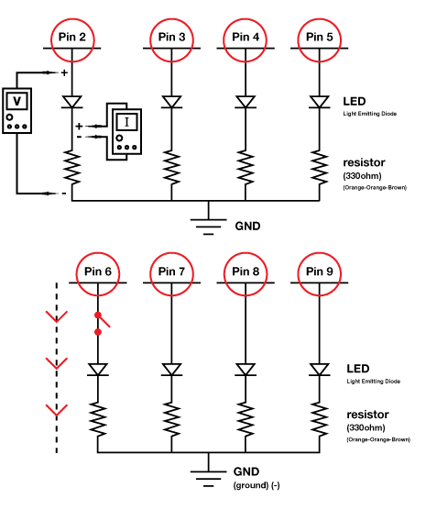
Give values for Voltage, Current and Resistance for each LED circuit setup. Find Resistance with Ohm's Law. Hint: Break the circuit between Arduino pin and LED to measure the current.

PWM @ 63.75 (or 25%)

V = 1.18__v I = _2.06_mA R = _572__Ω
PWM @ 127.5 (or 50%)

V = _2.37_v I = _4.17_mA R = _568__Ω
PWM @ 191.25 (or 75%)

V = _3.57_v I = _6.3__mA R = _566_Ω
PWM @ 255 (or 100%)

V = _4.77_v I = _8.4__mA R = _568_Ω

Circle all the Power Sources (This one is a little trickier).

Draw arrows to indicate direction of current on dotted line.

Add an on/off switch for one LED to this schematic.

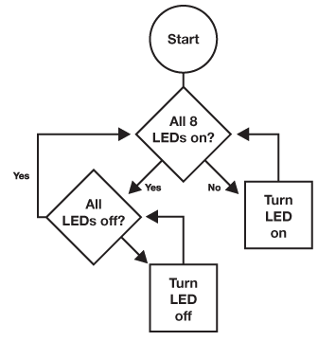  Draw a logic flow chart of the circuit here: | Draw one example of how this circuit could be used in everyday life. Label all components and give it a title.
What circuits or projects would you like to add LEDs to? Can you think of at least three reasons you might add multiple LEDs to an existing circuit or product that you would use? For example: clock that shuts off an LED every time you are done with a class, turning off all the LEDs by the end of the day so you know you are free.
________________________________________________________________________________________________________________________________________________________________________________________________________________________________________________________________________________________________________________________________________________________________________

