SIK Worksheets v.1.0 Name:
Circuit 1, Middle School Date:

Ohm's Law: V = I * R I = V / R R = V / I

How is this circuit, or a circuit like it, used in everyday life? Provide at least three examples.
_________________________________________________________________________________________________________________________________________________________________________________________________________________________________________________________

Did you get your LED turned on? Great. Make sure it's red. Switch the Arduino pin # 9 with 5v on the Arduino.

Give values for Voltage, Current and Resistance for each LED circuit setup. Find Resistance with Ohm's Law. Hint: Break the circuit between the Arduino pin and LED to measure the current. Place LEDs in series.  330Ω (circuit as is):  V = __5___v I = __9.2_mA R = __543__Ω  With two LEDs and 330Ω :  V = __5___v I = __3.7_mA R = __1.35KΩ  One LED and 10KΩ resistor:  V = __5___v I = __.32_mA R = __15.6KΩ  Two LEDs and 10KΩ resistor:  V = __5___v I = __.15__mA R = _33.3KΩ  Circle the Ground.  Draw arrows to indicate direction of current on dotted line.  Add an on/off switch to this schematic. | For questions that use multiple LEDs make sure you  place additional LEDs between the multimeter leads.  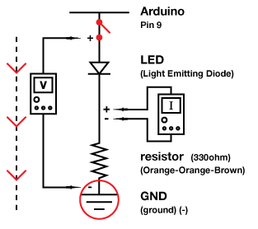
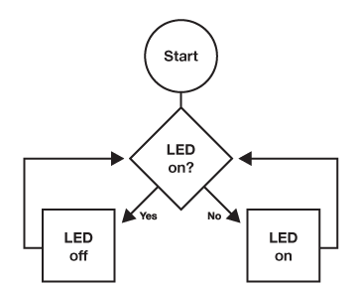  Draw a logic flow chart of the circuit here: | Draw one example of how this circuit could be used in everyday life. Label all components and give it a title.
What circuits or projects would you like to add LEDs to? List at least three reasons you might add LEDs to an existing circuit or product that you might use. For example: to indicate when a squirt gun is running low on water or to add a flashlight to your hat.
_________________________________________________________________________________________________________________________________________________________________________________________________________________________________________________________

