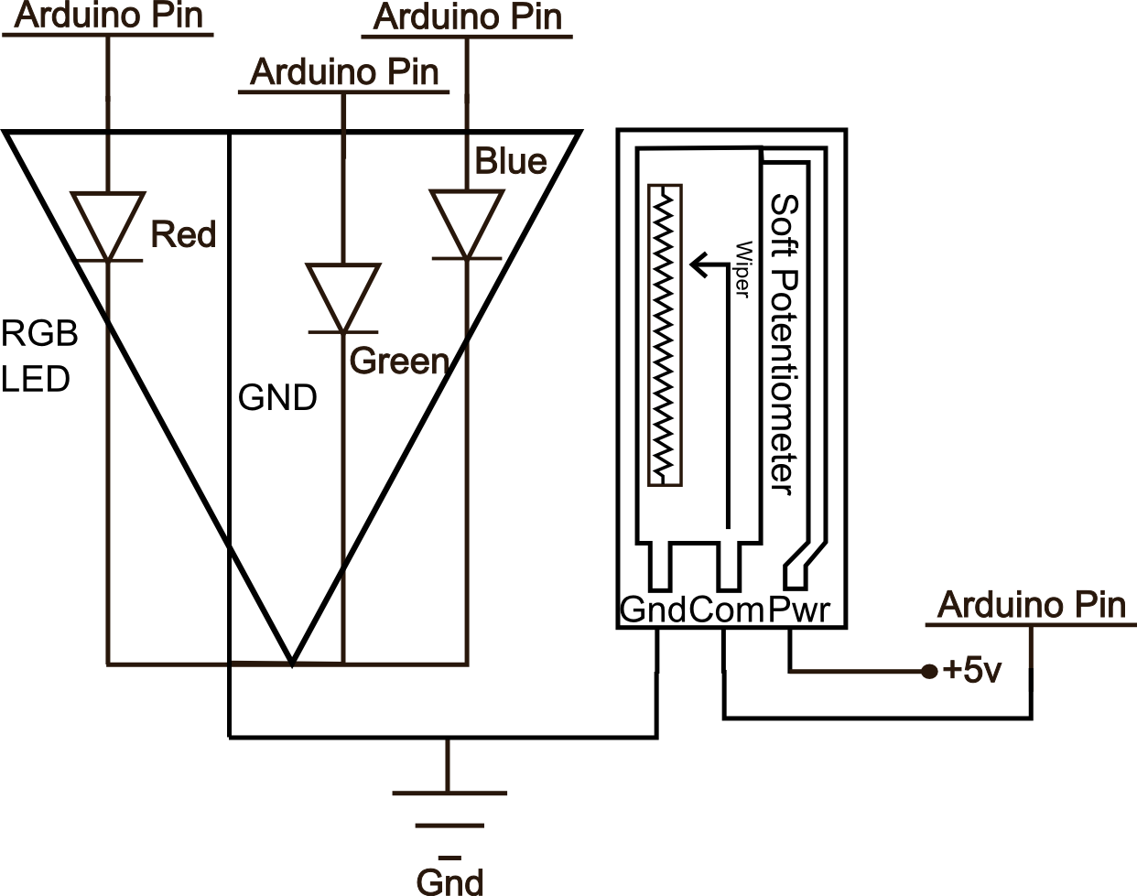
SIK Worksheets v.1.0 Name:
Circuit 14, High School Date:

The soft potentiometer is very touchy, sometimes you will notice incorrect readings due to how you touch the sensor. Be careful not to touch below the sensor pad, you will short out the sensor. Also the sensor reads a value even when you are not touching it. Explain how this alters the ways in which you can use this sensor. Explain at least one possible fix or work around.
_The sensor gives a false positive reading when it is not being touched. One possible work around is to make contact at the point where it reads zero (bottom of sensor) whenever the sensor is not in use.____ ___________________________________________________________________________________

Add the underlined code to your Arduino code.  In setup: Serial.begin(9600);  In loop (at end): Serial.println(sensorValue);  delay(100);  Now open the Serial Communication window.  This will let you see the values (slowed down a little with the delay line, to see real time output remove delay(100);) as the soft trimpot outputs them. What happens to the values after you stop touching the sensor? Explain why you think this happens.  __The values slowly return to their original value. This is because the two layers tend to stick together.  ___________________________________________________________________________________________________________________________  Give values for sensorValue, Voltage, Current and Resistance for each question. To measure resistance; disconnect trimpot, press area that corresponds to color and attach the multimeter to the com line and ground. Find Current by calculating with Ohm's Law.  RGB:red:V = 5-1mv I = .05-.02mA R =100-50Ω  sensorValue = 1-0ish__  RGB:blue:V =4.99-4.9 v I =.47-.467mA R= 10.6K-10.5KΩ sensorValue = 1023ish  RGB:green:V =1.7-1.3v I =.34-.325mA R=5K-4KΩ  sensorValue = _460ish  RGB in yellow range:V =1-.36v I = .2-.24mA R = 2K-1.5KΩ sensorValue = _245ish  What RGB PWM values do you need to display purple?  _Red: 255, Green: 0, Blue: 255____________________ | Touch the sensor lightly (don't push or hold it) and run your finger from one end to the other. What happens? Why do you think this is? Explain.  _The sensor reads about 500 – 600 no matter where you touch it. This is because there is more pressure necessary to close the connection between the layers of the sensor._______________________________  You can make the RGB LED display red when you touch the bottom and blue when you touch the top by changing two lines of code. Write one these lines of code below as well as what you need to change it to.  _int redValue = constrain(map(sensorValue, 0, 512, 255, 0),0,255);_to_int redValue = constrain(map (sensorValue, 512, 1023, 0, 255),0,255);__________  Write an if statement you could add to your loop() method that causes the RGB LED to display purple when you touch the absolute top of the trimpot.  _if(sensorValue == 1023){analogWrite (RED_LED_PIN, 255) analogWrite (GREEN_LED_PIN, 0) analogWrite (BLUE_LED_PIN, 255)} ___________
Imagine your soft potentiometer is thirty feet long. Explain at least three things you could use it for.
______________________________________________________________________________________________________________________________________________________________________
SIK Worksheets v.1.0 Name:
Circuit 14: Date:

Soft potentiometers come in a bunch of shapes and sizes. Explain how you could combine two soft potentiometers, two servos and a slingshot to create a machine that launches marshmallows (because they are soft) at wherever the two soft potentiometers tell it to, include a schematic or logic flow chart in the blank section .... or just go build one instead of explaining how it might work. You've finished the SIK, what are you waiting for? In fact, forget these guiding questions, if you want just use this page to brainstorm what your next project will be.
_____________________________________________________________________________________________________________________________________________________________________________________________________________________________________________________________________________________________________________________________________________________________________________________________________________________________________________________________________________________________________________________________________________________________________________________________________________________________________________________________________________________________________________________________________________________________________________________________________________________________________________________________________________________________________________________________________________________________________________________________________________________________________________________________________________________________________________________________________________________________________________________________________________________________________________________________________________________________________________________________________________________________________________________________________________________________________________________________________________________________________________________________________________________________________________________________________________________________________________________________________________________________________________________________________________________________________________________________________________________________________________________________________________________________________________________________________________________________________________________

