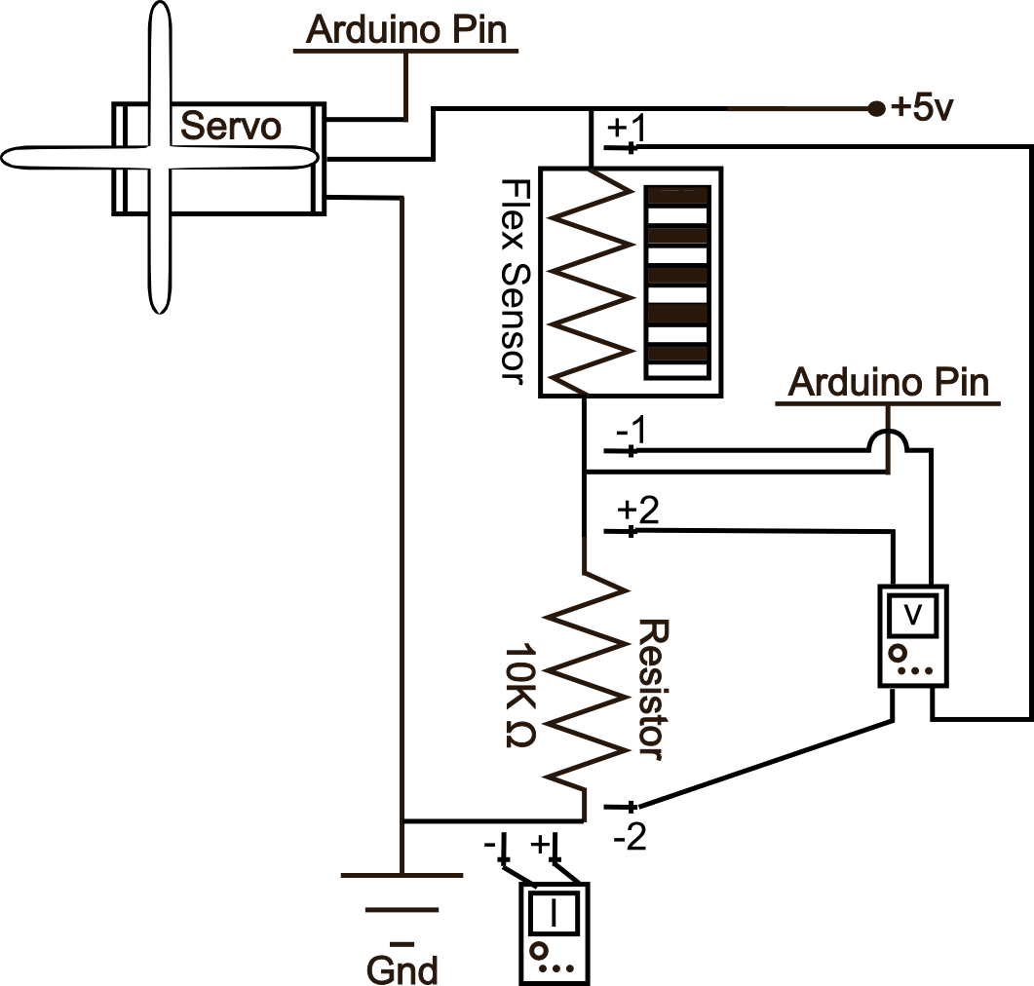
SIK Worksheets v.1.0 Name:
Circuit 13, High School Date:

Now we're starting to work with some more complicated sensors. The flex sensor has tons of real world applications. List three and explain why you can't use a regular potentiometer instead of a flex sensor. Example: use the sensor to measure the flex on a fishing pole and cut the line if the pole ever comes close to breaking. You could not use a potentiometer because it would be difficult to attach it.
_________________________________________________________________________________________________________________________________________________________________________________________________________________________________________________________

Got your flex sensor and servo working? Great.

Give two values for Voltage, Current and Resistance for each multimeter placement. The first value is without bending the flex sensor and the second is with the flex sensor bent so the sensor creates a half circle. Don't crimp the flex sensor, just bend it. Find Current by breaking the circuit and using the multimeter.  Multimeter 1, no bend:  V = _3.68_v I = _.12__mA R = 30.66kΩ  Multimeter 1, with bend:  V = _4.5__v I = _.03__mA R = _150k_Ω  Multimeter 2, no bend:  V = _1.2__v I = _.12__mA R = _10k__Ω  Multimeter 2, with bend:  V = _.3___v I = _.03__mA R = _10k__Ω  For each multimeter position mark two Xs in additional places where you could attach the multimeter (positive and negative) to get the same readings as above. | 1x+ 1x+  2x+ 2x+  1 & 2 x-
Using a protractor to measure the servo angle, and the Serial Monitor to output the analogRead value of the flex sensor, create a graph that shows how these two values correlate. Remember to label your graph.  There are different kinds of flex sensors. List at least 3.  ___Conductive ink based flex sensor, fibre optic flex sensor, conductive fabric/polymer flex sensor_  Which kind of flex sensor are you working with now?  ___Conductive polymer_____________________  What other kinds of sensors is this similar to?  ___Similar to a soft trimpot, sort of similar to a potentiometer______________________________ | How could you figure out the values for the second multimeter placement given the first set of values?  __The current for each of the bend values will be the same for the second set of values, and the voltage for each bend value will be 5v – the voltage through the sensor. _________________  If the flex sensor itself is a resistor, why is the 10K resistor necessary? Explain.  _It is necessary because otherwise the Arduino Pin is reading either 5v or 0v because it would be on the power source or ground line. Also without the 10k when the flex sensor's resistance is equal to zero the circuit will short directly to ground.
Take your favorite hypothetical project that you have written about so far in these worksheets, explain how and why you might add at least one flex sensor to this project.
______________________________________________________________________________________________________________________________________________________________________

