SIK Worksheets v.1.0 Name:
Circuit 12, High School Date:

This LED has three inputs and three outputs. What other circuits have three inputs? Three outputs? Provide an example of each.
_________________________________________________________________________________________________________________________________________________________________________________________________________________________________________________________

Does the RGB LED work? Great. Hint for questions below: if you're really stuck add a button to your circuit that uses Serial.println(); to print RGB values when you press it.
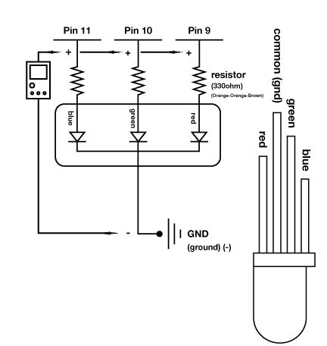
Connect a multimeter to each line that is connected to an Arduino pin. Notice how the voltage changes while you use the sensor or interface coupled with each pin.

What should the voltage values for each pin be to make the RGB LED as red as it will get?

Pin 11 V = __0_v Pin 10 V = __0_v Pin 9 V = __5_v

What should the voltage values for each pin be to make the RGB LED as yellow as it will get?

Pin 11 V = _0__v Pin 10 V = 2 to 3v Pin 9 V = __5_v

What should the voltage values for each pin be to make the RGB LED as white as it will get, but at 1/2 intensity?

Pin 11 V = _2.5v Pin 10 V = _2.5v Pin 9 V = _2.5v

Given that there are 256 (0 – 255) different intensity values for each color in an RGB LED, how many different colors can an RGB LED emit? Show you work.  __256 * 256 * 256 = 16777216 different colors!_  How many different colors can a RGBY LED emit?  __256 * 256 * 256 * 256 = 4294967296_________  Why are there 256 LED intensities, and not 300?  __That's # of values in PWM b/c it has 8 bits of memory allotted for one PWM value. ___________ | Light is a small part of a big group of electromagnetic  fields called the Electromagnetic Spectrum. Name at  least three other electromagnetic fields and state if  their frequencies are higher or lower than light.  _Higher: Radio, microwave, infrared._________  Lower: X-rays, gamma rays.________________  _______________________________________  Who discovered the theory of Electromagnetic  Spectrum? Who expanded it beyond light?  M. Faraday & J. Maxwell, H. Hertz expanded it.

Upload Circ12bExpansion to your Arduino and add a piezo element to digital pin # 1. Change the code so you don't go crazy listening to “Twinkle, Twinkle Little Star”. Explain how you could add another RGB LED so it also changes color depending on the note your piezo plays, but with different code so it displays a different color.
_Inverse the sensorValue using Map method and then save to a different variable. Use different PWM pins to display these values in a different RGB LED. Or something like that. __________________________________
__________________________________________________________________________________________

Other than Red, Green and Blue, what else could RGB stand for? Example: Roasted Gooey Baloney, Random Gargantuan Baboons, Rappers Got Beef, or Robot Guild Butlers. List at least three original possibilities.
_________________________________________________________________________________________________________________________________________________________________________________________________________________________________________________________

