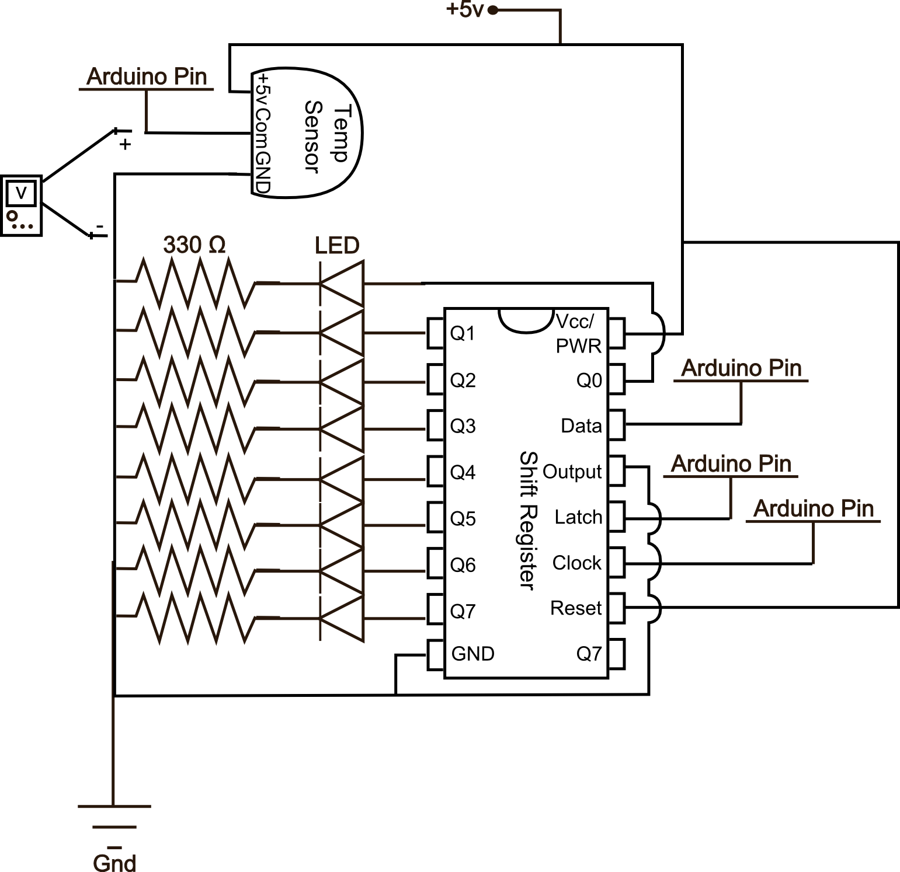
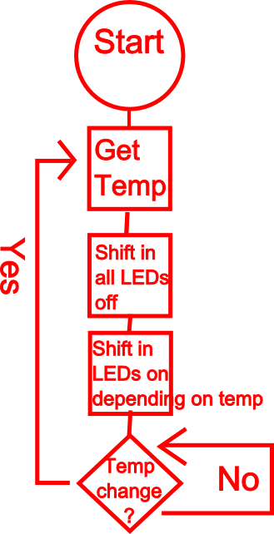
SIK Worksheets v.1.0 Name:
Circuit 10, High School Date:

How is this circuit, or a circuit like it, used in everyday life? Provide at least three examples.
_________________________________________________________________________________________________________________________________________________________________________________________________________________________________________________________

Does your temperature sensor work? Great. Upload Circ10BExpansion Code to your Arduino. Attach the shift bit register and LEDs as shown in the schematic below. You may have to alter some code depending on how hot or cold it is where you are.

Give values for Voltage for the two temperature values below. Also record the amount of LEDs that light up with each temperature. For the first temperature use whatever temperature your room currently is.  75.2°F ≈ 24_°C (room temperature, fill in degrees)  V =_.703_v LEDs =_4_  98.6°F = 37°C (use a cup of cocoa to warm up sensor)  V =_.837_v LEDs =_8_  50°F = 10°C (use an ice pack to cool down sensor)  V =_.577_v LEDs =_0_  Using the values above, formulate an equation so you can calculate values for the temperatures below.  105°F ≈ 40.5°C V =_.872_v LEDs =_8_  86°F ≈ 30°C V =_.763_v LEDs =_6_  32°F ≈ 0°C V =_.477_v LEDs =_0_  -49°F ≈ -45°C V =_.027_v LEDs =_0_ X  It is impossible to get a reading for one of the temperatures above. Place an X beside this value. | Write the equation below that solves for the change  in voltage (V) given a change in temp (X).  V≈.477+X*.01(equation will vary) actual: V=.5+X*.01  equation & answers vary slightly due to sensor variance
Draw a Logic Flow Chart of the circuit here: | There are four main types of temperature sensors, thermocouples, resistance temperature detectors, thermistors, and temperature-transducing ICs. Which one are you playing with and is it analog or digital?  _The tmp36 is a resistance temperature detector and an analog sensor, that's why it plugs into an analog in Arduino pin._______________________  How is this similar to a LED? To a motor?  _This is similar to an LED and a motor because it uses analog values. The LED and motors do not use analog values, but PWM is the digital equivalent._ _________________________________________
Find a way to quickly change the temperature read by your sensor. How fast can you get it to change by 20°F?
___________________________________________________________________________________

