SIK Worksheets v.1.0 Name:
Circuit 9, High School Date:

Now you are going to use your SIK to create an alarm system using analog and PWM signals. Upload the Circ9Expansion Code onto your Arduino and setup your breadboard according to the schematics below.
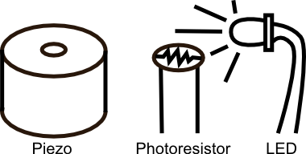
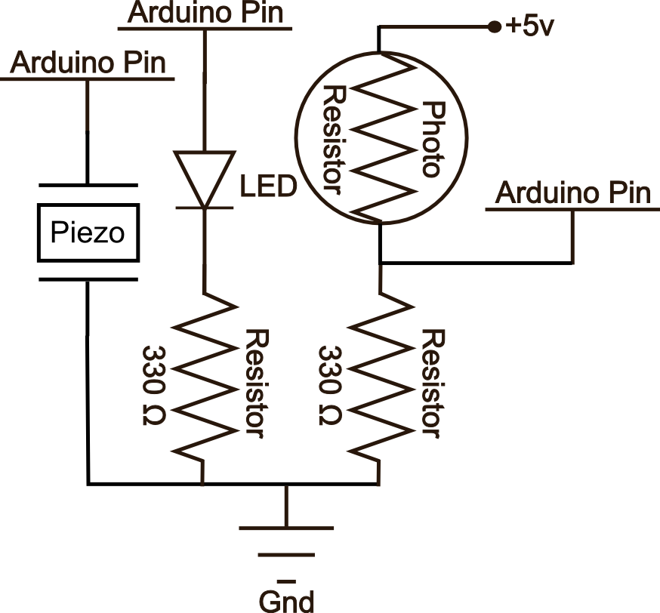
This simple alarm is designed so that when something comes between the light source (LED) and the photoresistor the piezo element starts it's annoying beeping. If you open your Serial communicator you will see it printing out a PWM value for the strength of the LED and an analog value for what the photoresistor sensor is receiving in the way of light. Without changing any of the code your alarm should work if you turn off the lights and pass your finger between the LED and the sensor.

What changes in this circuit and causes the alarm to go off? It's not just a lack of sunlight. Explain what is happening with the electricity. Write and explain the exact variable that changes as well as the value below which the alarm is triggered.
_When the light is reduced the photoresistor supplies a lower voltage to the analog in pin on the arduino. This reduces the lightLevel variable and when it reaches less than 50% (or less than 511) the piezo element is triggered my the alarmSound method. The alarmSound method runs until it has played the entirety of “Twinkle Twinkle Little Star”. ______________________________________________ _____________________________________________________________________________________________________________________________________________________________________

In order to make the alarm work during daylight you will need to be out of any direct lighting and you will need to change one of the values in the code. Write the line you changed in the code below and explain why.
_if(lightLevel < 511 { should be changed to if (lightLevel < 750{ so that the light doesn't need to go down as much in order for the alarmSound method to be triggered (value may be different than 750). This is because there is ambient light that is not emitted by the LED so we need to compensate for that. _________________________________________________________________________________________________________________________________________________________________________________________________________________________________________________________

What component in the SIK do you think you could use to physically change the sensitivity of the photoresistor so you don't have to change the code whenever the sunlight levels change? Explain how.
__You can use a potentiometer to change the resistance of the photoresistor circuit. This way if there is more sunlight you could turn up the potentiometer, thereby decreasing the voltage the circuit emits and vice versa. _________________________________________________________________________
___________________________________________________________________________________

