SIK Worksheets v.1.0 Name:
Circuit 7, High School Date:

How is this circuit, or a circuit like it, used in everyday life? Provide at least three examples.
_________________________________________________________________________________________________________________________________________________________________________________________________________________________________________________________

Can you turn your LED on and off using both buttons? Great. Upload Circ07Expansion Code to your Arduino and add an RGB LED to pins 9, 10 and 11. Check the code if you are unsure which leads go to which pins.

The buttons in your circuit now adjust the variable “RGBValue” either up or down. What are the upper and lower parameters of “RGBValue”?  ___255 and 0.______________________________  With the code as is, what happens if you press the “down” button while pressing the “up” button? Why do you think this is?  _The second buttons that is pressed does not work.  This is because the code checks to see if one button is pressed at a time and while that button is pressed runs one line of code until button is released._____  What could you add to the code to fix this bug?  _another IF statement inside the buttonPress == HIGH IF statement that checks to see if the other button has been pressed. If the other button is pressed while the first is pressed then have color variable go down instead of up and vice versa. ________________________________________ | In the code below underline the command that  happens when the button is not being pressed.  void loop()  {  buttonState = digitalRead(buttonPin);  if (buttonState == HIGH) {  digitalWrite(ledPin, HIGH);  }  else {  digitalWrite(ledPin, LOW);  }  }  Explain the difference between = and ==.  __= sets a variable equal to something. ==  compares a variable to something.___________  _______________________________________  _______________________________________  _______________________________________  _______________________________________
Draw a Logic Flow Chart of the expanded circuit here:  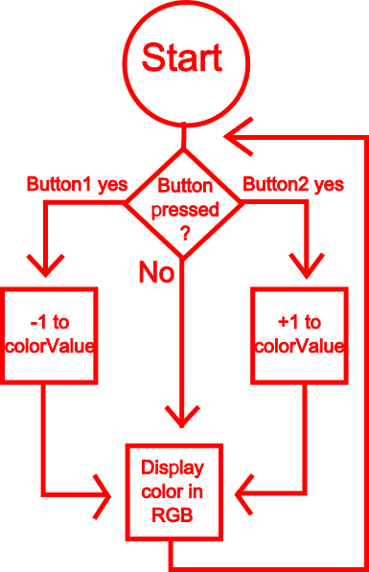 | In the space below draw the symbols for a two way switch (SPST), a three way switch (SPDT), and a double pole switch (DPST). Label all three.  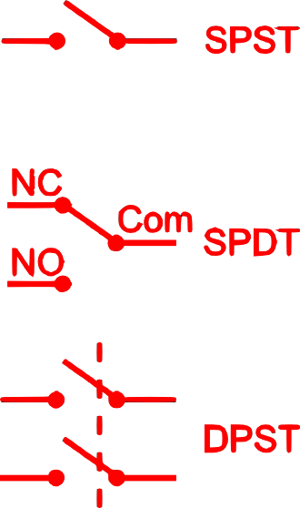

Buttons are everywhere, however it is possible to substitute other user interface components for buttons, list at least three components that you could switch with a button in some way.
__Potentiometer, a relay, a shift register, a temperature sensor, a flex sensor, or a soft potentiometer.___
___________________________________________________________________________________

