SIK Worksheets v.1.0 Name:
Circuit 5, High School Date:

The byte in this circuit's shift bit register is used to turn LEDs on and off. It can also be used to represent many other types of data in binary. Explain how a number is written in binary, then write nine using ones and zeros.
__A number is written in binary by representing it in base 2 mathematics. For example one is 1 but two is 10 and 4 is 100 and 5 is 101 and 9 is 1001. It's easier to show than to explain.___________________
_________________________________________________________________________________________________________________________________________________________________________________________________________________________________________________________

Does your shift bit register light up all the LEDs in a pattern? Great.

Explain why the shift register needs the clock pin as part of how it operates.  _The clock tells the shift register when to shift a new set of data in because it is ready to accept data for a new pin. When the clock rises a pin is set.  Fill in the diagram below if you were trying to shift in the following bits for data: 11100110  Latch:  Clock:  Data:  On the schematic to the right label the most significant bit's pin with MSB and the least significant bit's pin with LSB. | 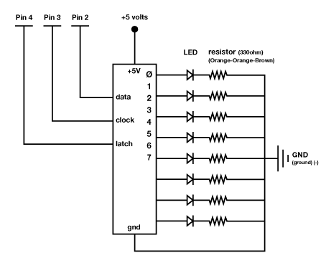  MSB  LSB
Assume the byte below is in your shift register chip.  Most significant bit Least significant bit  (MSB) ---> 1 0 1 1 0 1 0 0 <--- (LSB)  While shifting bits in and out of your chip you can move them so you drop either the MSB, or the LSB. Assuming you drop the LSB and are adding a 1 to the byte above, what is the resulting byte?  ____11011010______________________________ | A little history:  What was one of the first known uses of the shift bit  register?  ____One of the first know uses was in Colossus a  code breaking machine in the 1940s. It was used  during WWII by the British to decode  intercepted German communication.__________  _______________________________________  _______________________________________
This shift register and LED combination is a powerful display or interface circuit. Explain a sensor or two you might attach to this circuit and what the LEDs attached to the shift register would signify. Example: connect a mic and each LED would represent a different musical note heard by the mic.
_____________________________________________________________________________________________________________________________________________________________________________________________________________________________________________________________________________________________________________________________________________________________________________________________________________________________________________________________________________________________________________________________________________________________________________________________________

