SIK Worksheets v.1.0 Name:
Circuit 5c, High School Date:

Got your shift bit register lighting up all the LEDs in a pattern? Great. Upload Circ05Expansion to your Arduino and add two buttons, two LEDs and a trimpot to your circuit, use the schematic below for reference.
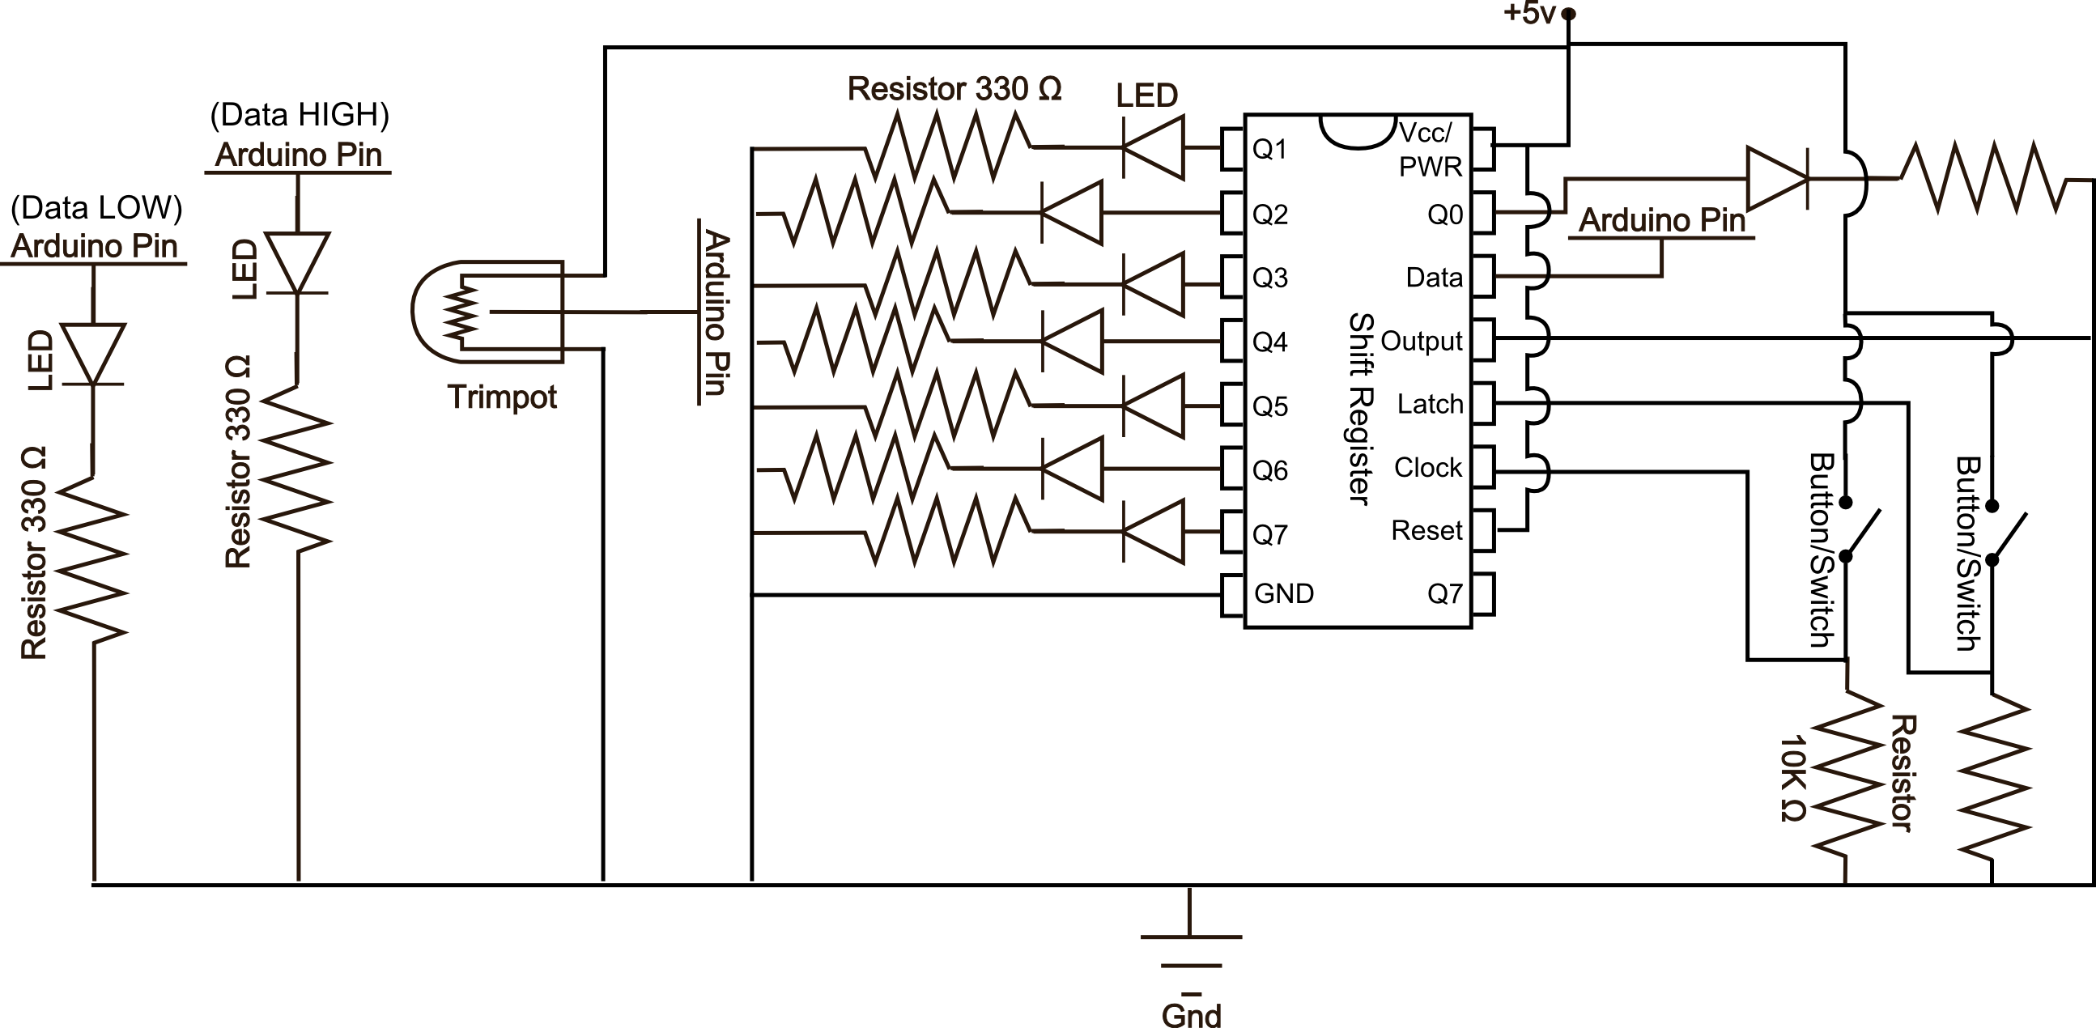
Your two buttons now pulse the clock and latch the shift register. You will use the trimpot to set your data either HIGH or LOW. Play with the trimpot to figure out which way is HIGH and which way is LOW. One of the indicator LEDs will light up depending on the value. Then use the clock pulse button to send the data value to the shift register. To see the data that you have shifted into the register so far hit the latch button.

Before answering the following questions set your data pins all back to LOW, or off (Remember, LOW == 0).

Which circuit, original or expanded makes more sense to you?_____________________________________

Using this interface you have more control over the shift register than the original code. Explain the difference between the expanded circuit and the original. Use examples from the original code and explain what physical element has replaced it. Also explain what the various states of the physical elements are.
__In the expanded circuit the latch pin has been replaced by one of the buttons. When the button is not pressed it is HIGH and when it is pressed it LOW. This way the circuit is always ready for data. The data pin has been replaced by the potentiometer with the two LEDs to show if the “data” is HIGH or LOW. Lastly the clock has been replaced by the other button which is HIGH unless pushed._________ ___________________________________________________________________________________
Because you decide when to “latch” your data in you can control all the pins in any order you like as long as you “clock” in the proper sequence. This lets you decide which pins are ON or OFF without having to cycle through them all. Decide on eight different circuits (or objects) you would like to turn on and off using a register and then explain at least two different patterns you would send the shift register to control these objects. Use binary to write the patterns. Example: servo, servo, egg beater motor, spray on butter object, servo, waffle iron, servo, hot plate. 1111100: first two servos pour ingredients, egg beater mixes, butter sprays on waffle iron which is heating up, servo and hot plate off. 00000111: first two servos reset, egg beater off, no butter, waffle iron stays on, servo tilts waffle off of iron onto hot plate which keeps waffle warm. Note: Zero does not always mean off, it can make the circuit (or object) do something else, like reset a servo position or squirt syrup instead of butter.
__________________________________________________________________________________________________________________________________________________________________________________________________________________________________________________________________________________________________________________________________________________________________________________________________________________________________________________________________________________________________________________

