SIK Worksheets v.1.0 Name:
Circuit 5b, High School Date:

The byte in this circuit's shift bit register is used to turn LEDs on and off. It can also be used to represent many other types of data in binary. Explain how a number is written in binary, then write fifteen using ones and zeros.
__A number is written in binary by representing it in base 2 mathematics. For example one is 1 but two is 10 and 4 is 100 and 5 is 101, 9 is 1001 and 15 is 1111. It's easier to show than to explain.__________
______________________________________________________________________________________________________________________________________________________________________

Does your shift bit register light up all the LEDs in a pattern? Great. Upload Circ05Expansion to your Arduino and add two buttons, two LEDs and a trimpot to your circuit, use the schematic below for reference.

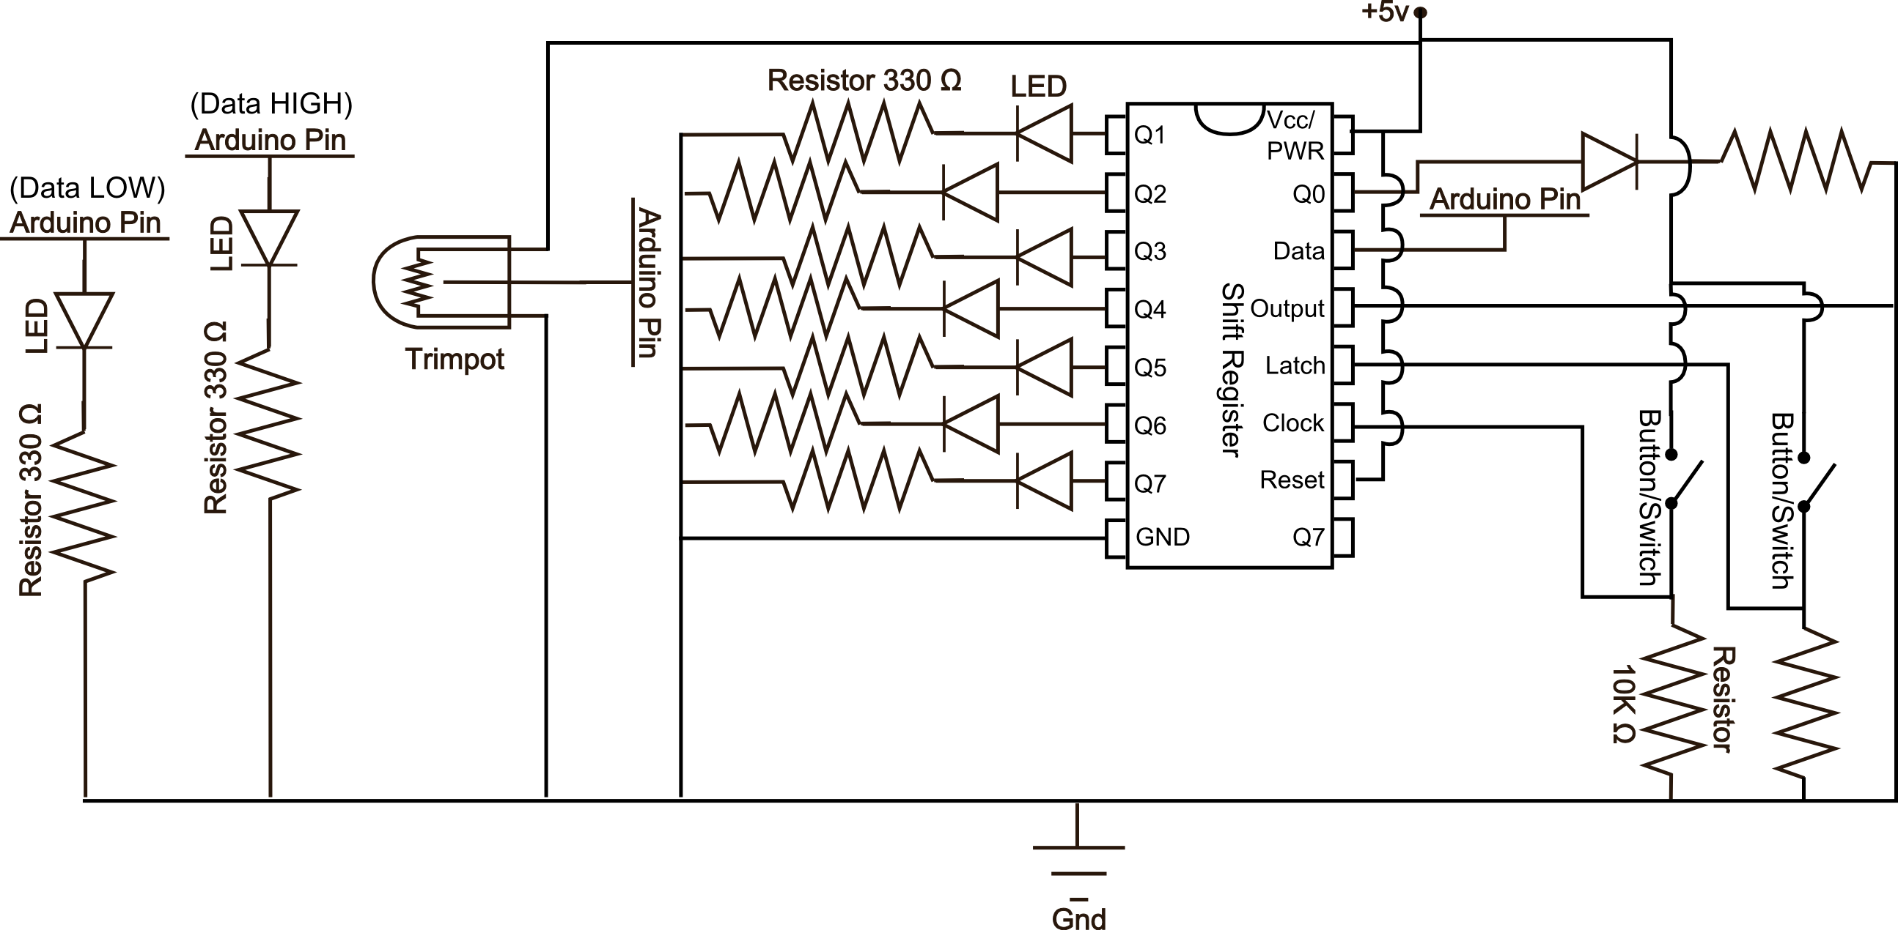
Your two buttons now pulse the clock and latch the shift register. Make sure you don't confuse the two! You will use the trimpot to set your data either HIGH or LOW. Play with the trimpot to figure out which way is HIGH and which is LOW. One of the indicator LEDs will light up depending on which value it represents. Then use the clock pulse button to send the data value to the shift register. To see the data that you have shifted into the register so far hit the latch button. To really get a feel for how shift registers work first set all the LEDs LOW, then start playing with different patterns of data values.

Before answering the following questions set your data pins all back to LOW, or off (Remember, LOW == 0).

Try setting just one data pin before hitting the latch button. What happens?  ___One LED changes. ______________________  __________________________________________  Now set seven data pins before hitting the latch button. What happens this time?  __Seven LEDs change. _____________________  ________________________________________ | Try setting eight data pins before hitting the latch button. What happens?  ___All eight LEDs change. __________________  _________________________________________  Now enter nine bits in the following order: 0,1,0,0,1,1,0,0,0. What does your LED pattern look like? Answer in binary.  __01001100_____________________________
Writing your answer in binary, explain how the LED pattern and shift register would act if you were shifting out the Most Significant Bit instead of the Least Significant Bit. Find the one command or word you would need to change in the code to make this happen and write it below. Just kidding about the binary thing.
___If one shifted out the Most Significant Bit instead of the least significant bit the LED pattern would shift in the opposite direction. If it was going from left to right before, it would shift from right to left instead. shiftOut(data, clock, MSBFIRST, value); would change to: shiftOut(data, clock, LSBFIRST, value); MSBFIRST to LSBFIRST also works.______________________________________________

