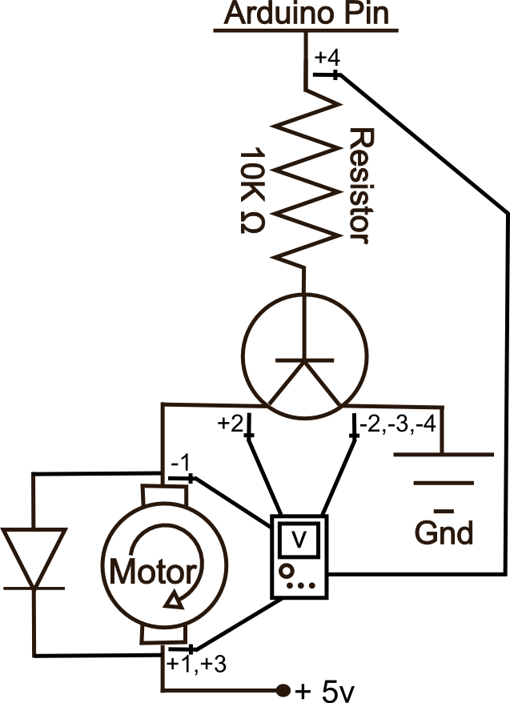
SIK Worksheets v.1.0 Name:
Circuit 3, High School Date:

How is this circuit, or a circuit like it, used in everyday life? Provide at least three examples.
_________________________________________________________________________________________________________________________________________________________________________________________________________________________________________________________

Got your motor running? Great. Upload Circ03Expansion Code to your Arduino. Fill in the answers below.

Give Voltage values for each PWM value listed at each multimeter location. You will need to change the code to measure the PWM values listed.  Position 1: PWM @ 100%, V = __3.65_v  Position 1: PWM @ 75%, V = __2.44_v  Position 2: PWM @ 100%, V = __1.06_v  Position 2: PWM @ 75%, V = __2.28_v  Position 3: PWM @ 100%, V = __4.76_v  Position 3: PWM @ 75%, V = __4.81_v  Position 4: PWM @ 100%, V = __4.74_v  Position 4: PWM @ 75%, V = __3.56_v  The amount the voltage decreases by as it passes through components is called voltage drop. What is the correlation between the various voltage drops you just measured?  PWM @ 100 requires more voltage than 75, except at position # 2, where excess voltage is shunted off. Positions 1 + 2 should equal a little under 5v. Position 3 should also equal a little under 5v. | Without using any code how could you make the  motor run the other direction?  __Switch the positive and negative leads on the  motor.__________________________________  _______________________________________  _______________________________________
In your own words explain what this transistor does and the ways in which the motor's action would change if it were hooked up directly to a 5V power source and a ground?  _The transistor acts as a switch. The higher the voltage from the Arduino pin the more current the transistor allows through to ground. ____________________________________________________________________________________________________________________________________________________________________ | A little history:  The word transistor is a combination of what  two words?  _____Transfer and resistor. _________________  ______________________________________  What was the first type of transistor to be mass  produced, and by who?  _____Silicon transistors mass produced by Texas  Instruments.____________________________
Transistors are used in almost ever piece of modern electronics and considered one of the most important inventions of the 20th century. What are some of your favorite items that contain resistors? Name at least five.
___________________________________________________________________________________________________________________________________________________________________________________________________________________________________________________________________________________________________________________________________________

