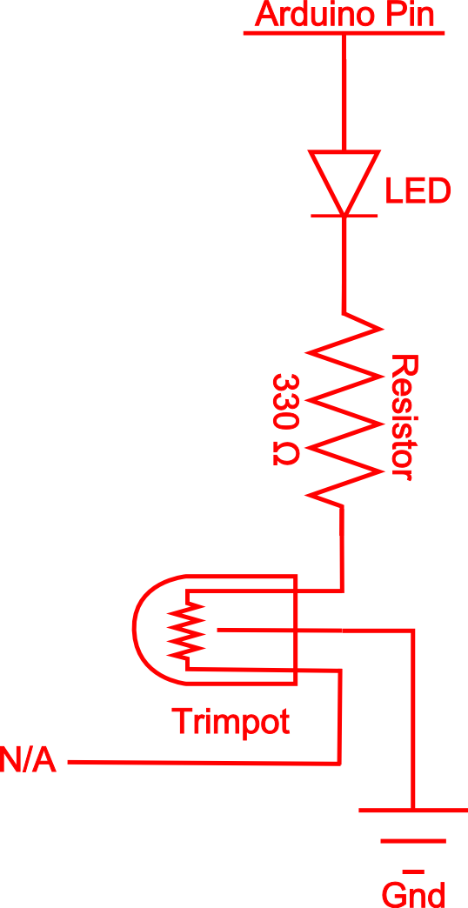
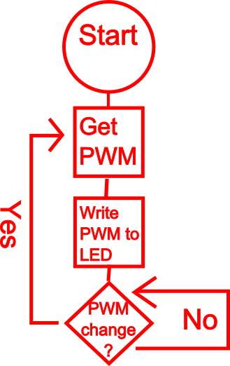
SIK Worksheets v.1.0 Name:
Circuit 2, High School Date:

How is this circuit, or a circuit like it, used in everyday life? Provide at least three examples.
_________________________________________________________________________________________________________________________________________________________________________________________________________________________________________________________

Get your LEDs turned on? Great. Now you are going to add a dimmer switch to your LED on pin # 9.

What user interface component will you need to use as a dimmer? _Potentiometer, or soft pot_________  Add the necessary text to the oneOnAtATime( )  method for the code heavy way to add the dimmer.  (See next page)  There are two different way to add a dimmer without changing or adding code. Try to find one of these ways without destroying your LED.  Draw a schematic of your circuit in the the space to the right, adding your dimmer component so that it works. There are three different ways to do this.  What other component does the dimmer component in this circuit act as?  __Resistor_______________________________ | Other options for schematics on next page.
The LED needs a PWM value that ranges from 0 – 255. The dimmer component gives you values from 0 – 1023. Write an equation below that will convert the value the dimmer component outputs to a LED friendly value.  __PWM = (dimmer/1024)* 256_______________  The LED values 0 – 255 actually represent 256 different values. Why is that?  __Zero is the first value but is not counted in the number system.____________________________  _________________________________________ | Draw a logic flow chart of the LED with dimmer.
Imagine your LED circuit (without dimmer) as a meter indicating a sensor reading. Decide what kind of sensor you would like to use as an input and describe in your own words what would cause the meter to rise and fall. ________________________________________________________________________________________________________________________________________________________________________________________________________________________________________________________________________________________________________________________________________________________________________
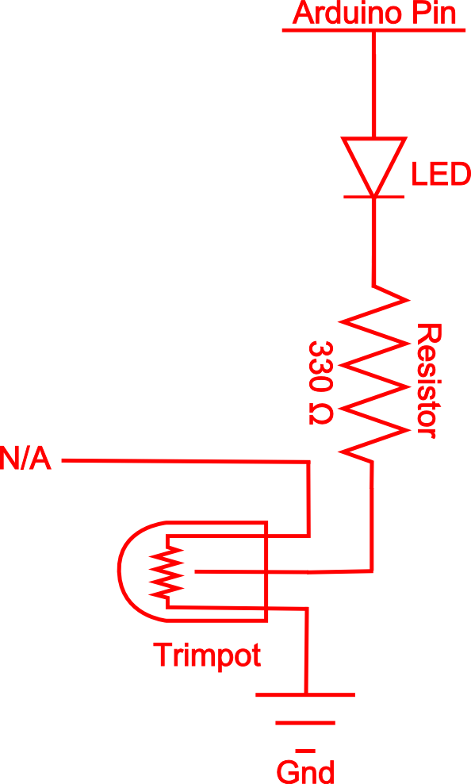
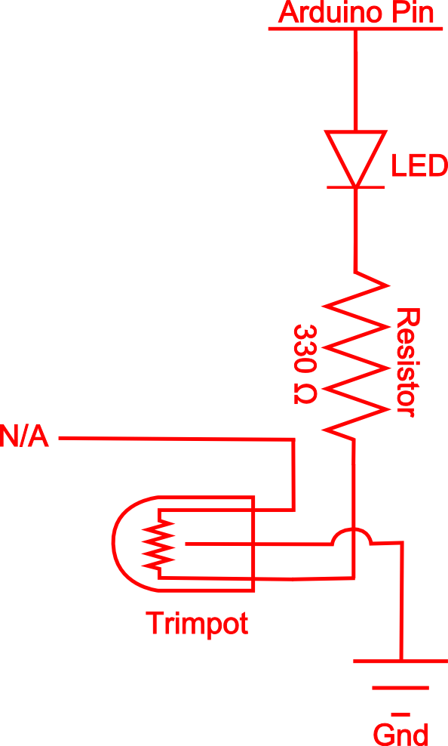
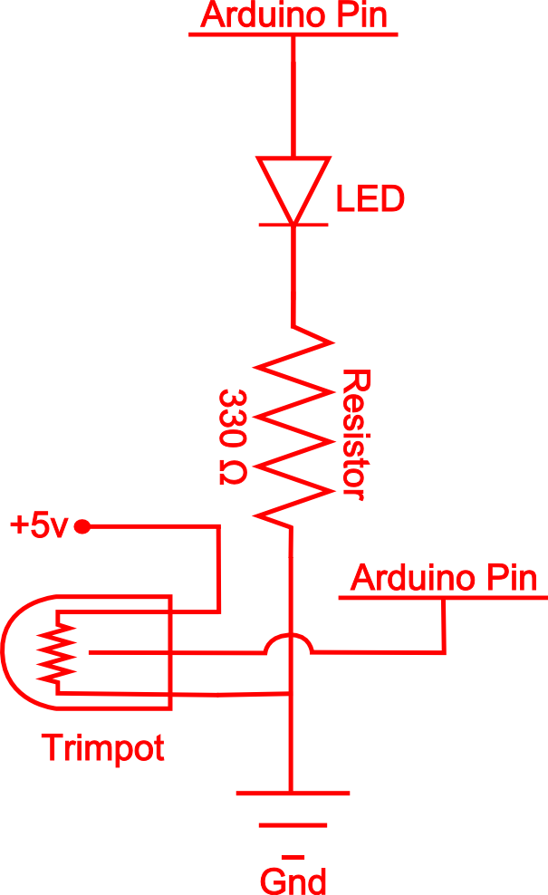
int trimpotPin = 0;

void oneOnAtATime(){
int delayTime = 100;
int sensorValue = map(analogRead(trimpotPin),0,1023,0,255)

for(int i = 0; i <= 7; i++){
int offLED = i - 1;
if(i == 0) {
offLED = 7;
}
analogWrite(ledPins[i], (sensorValue));
digitalWrite(ledPins[offLED], LOW);
delay(delayTime);
}
}
or

int trimpotPin = 0;

void oneOnAtATime(){
int delayTime = 100;

for(int i = 0; i <= 7; i++){
int offLED = i - 1;
if(i == 0) {
offLED = 7;
}
analogWrite(ledPins[i], (map(analogRead(trimpotPin),0,1023,0,255)));
digitalWrite(ledPins[offLED], LOW);
delay(delayTime);
}
}

